**CHINOOK INTEGRATION USING TALEND**

**TASK 2 MySQL to PostgreSQL**

Dim_Date

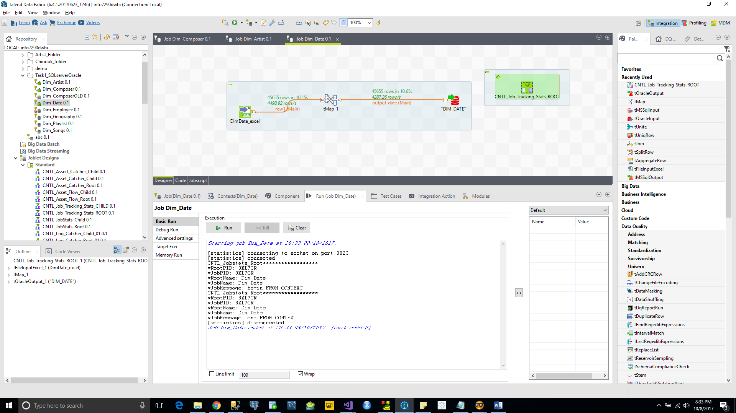

Artist

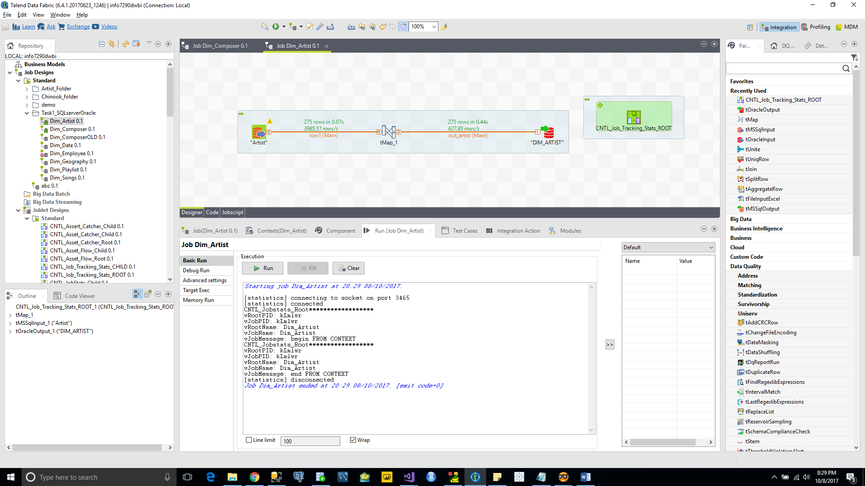

Composer

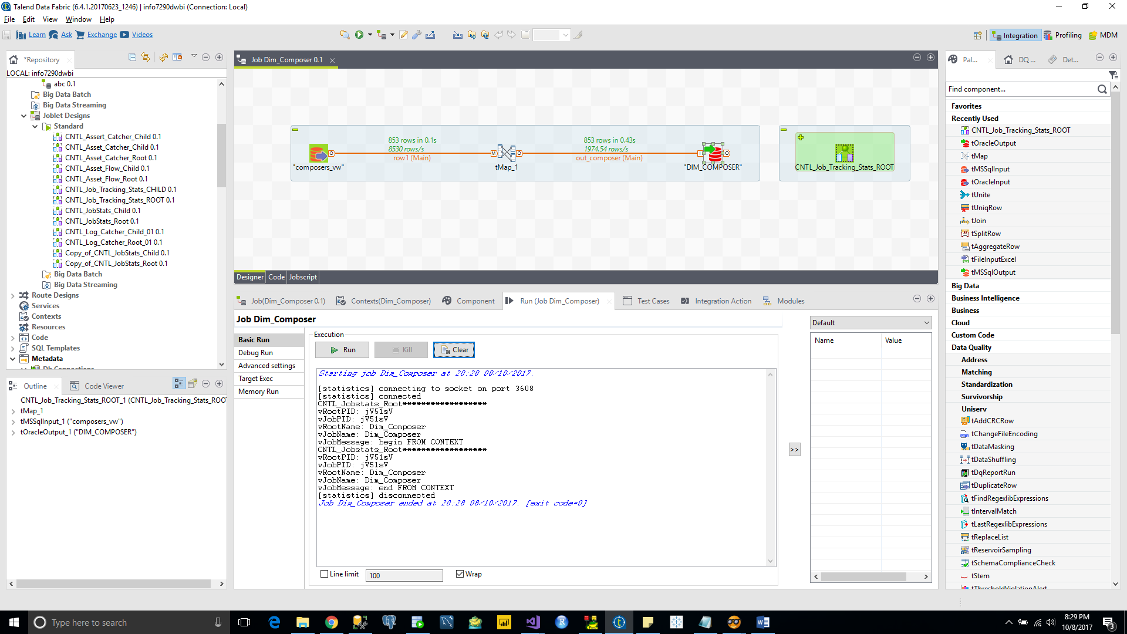

Dim_SONG

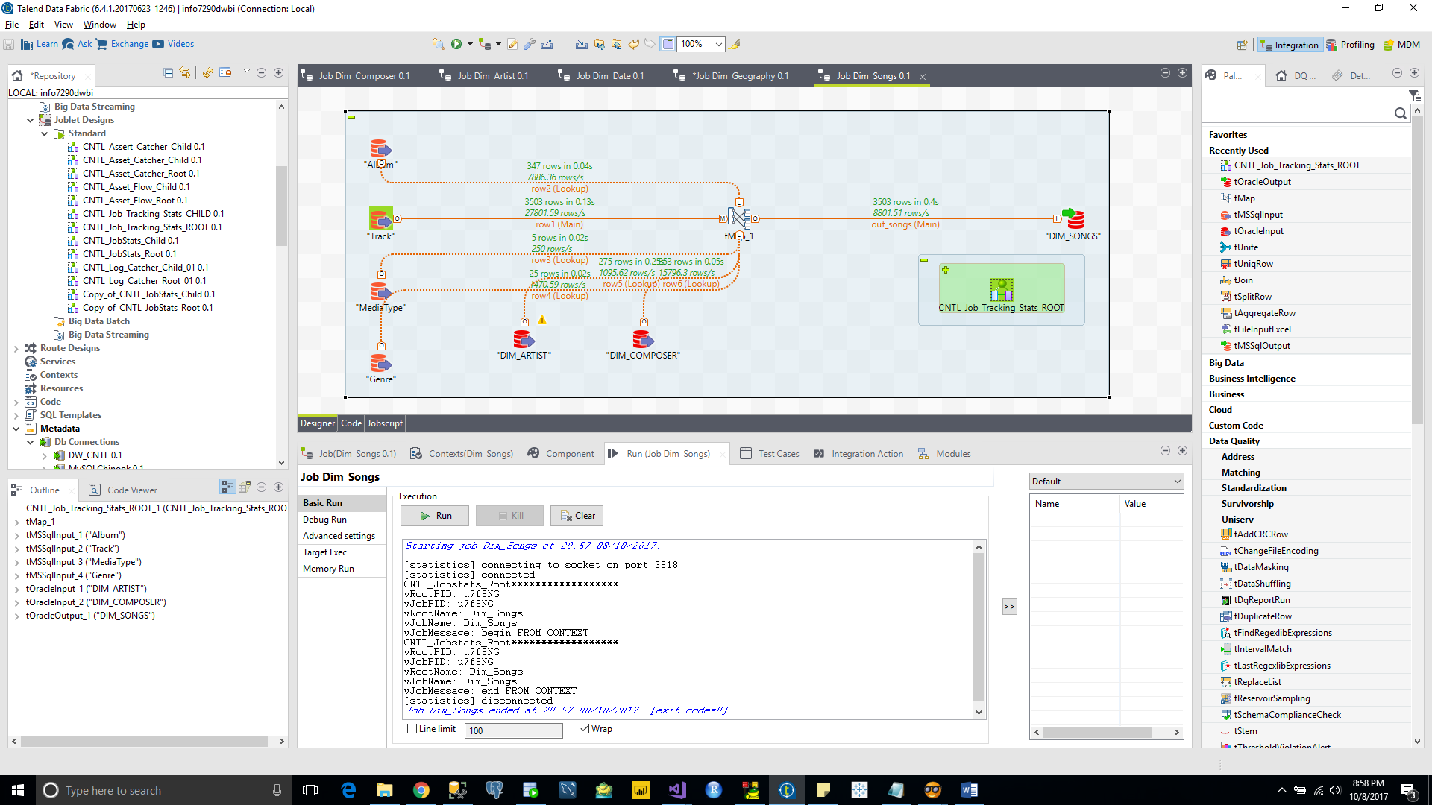

Dim_Playlist

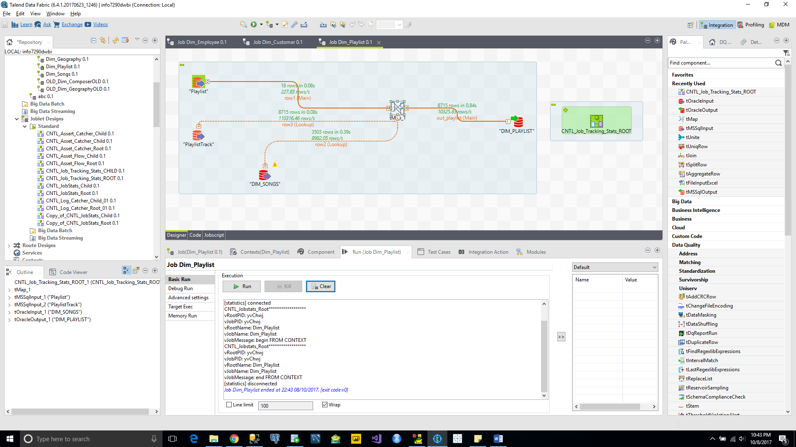

Dim_Employee

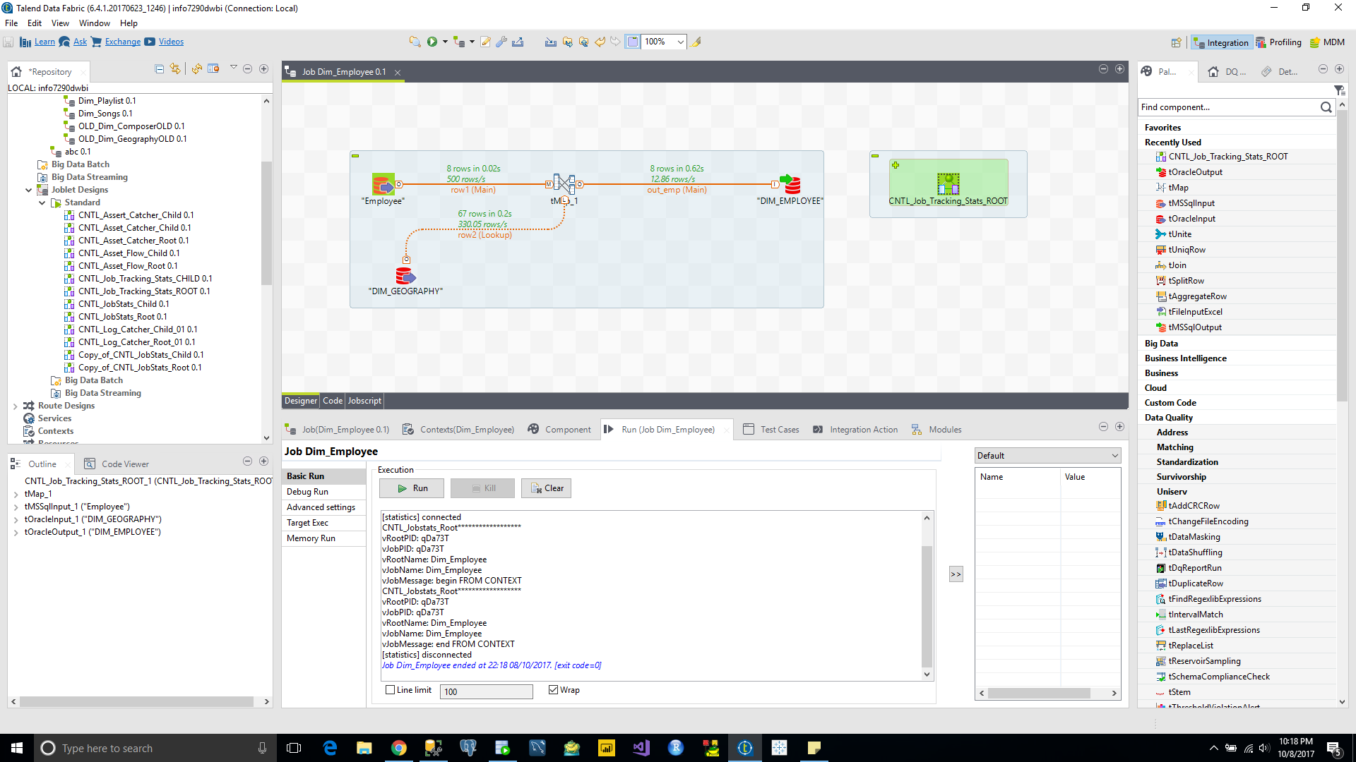

Dim_Customer

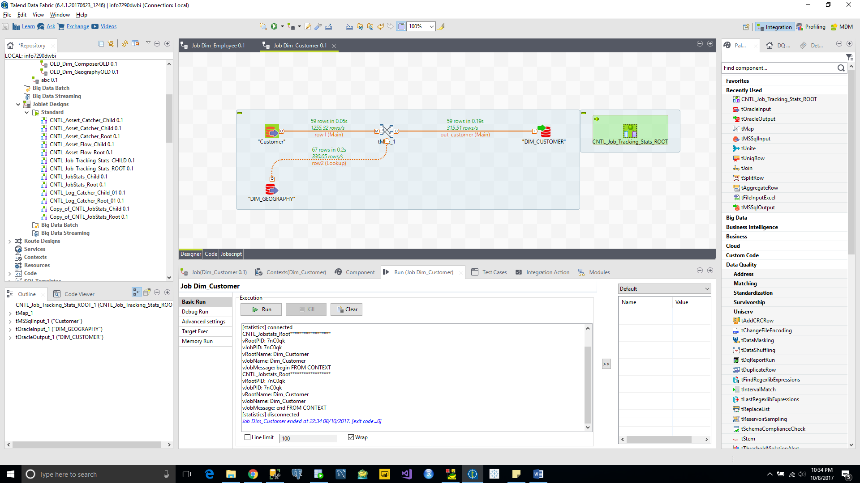

Dim_Geography (old)

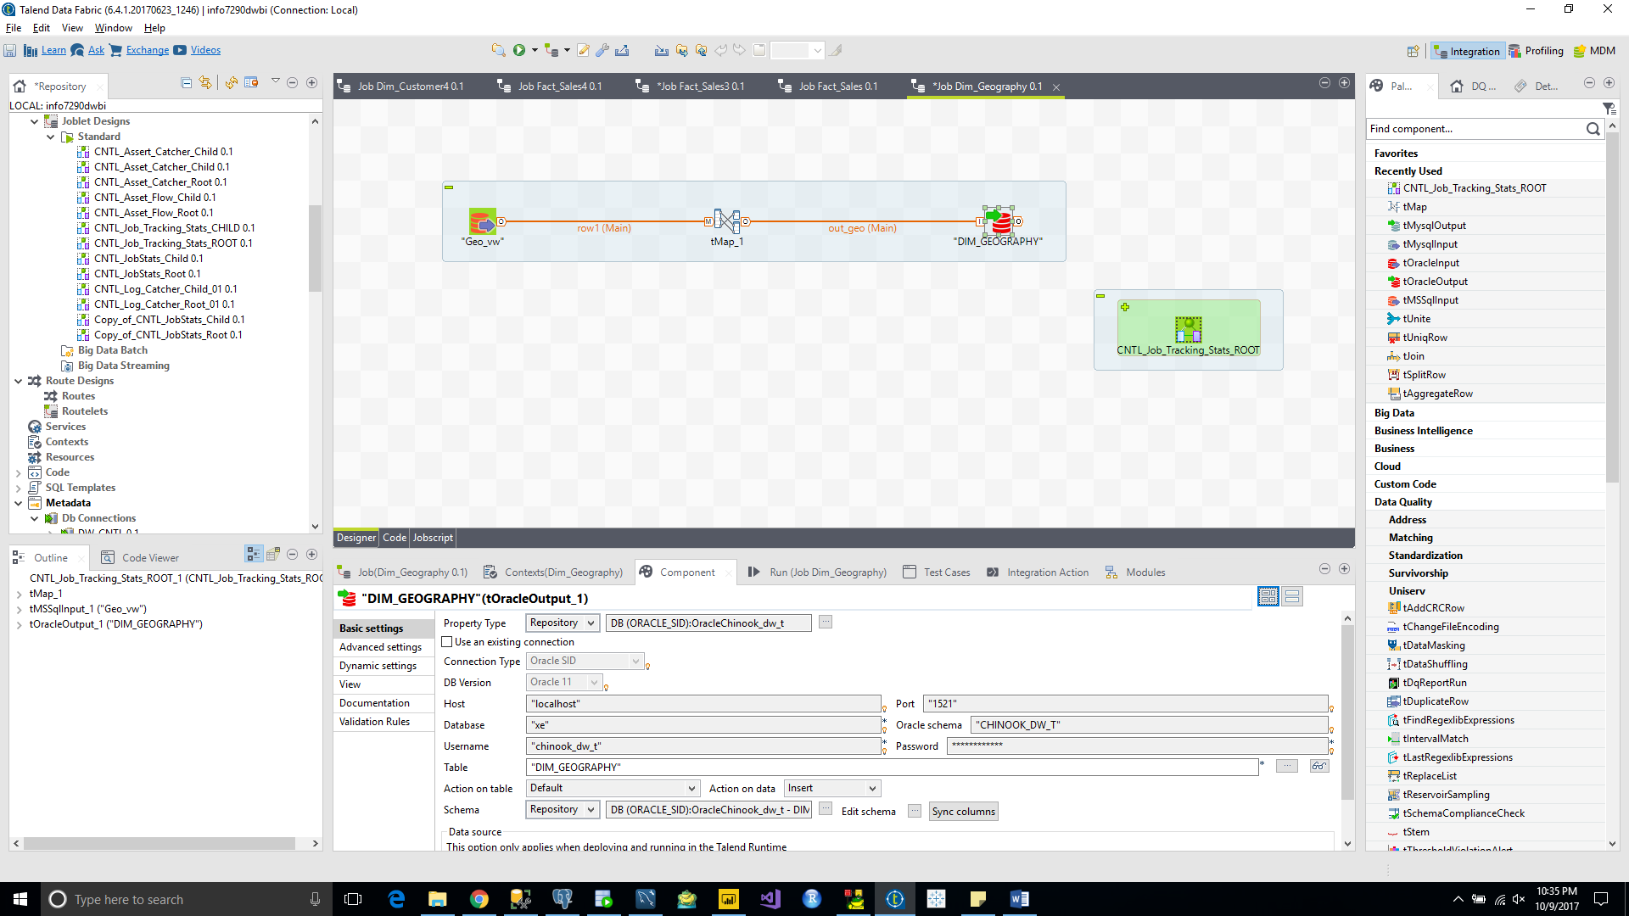

Fact_Sales

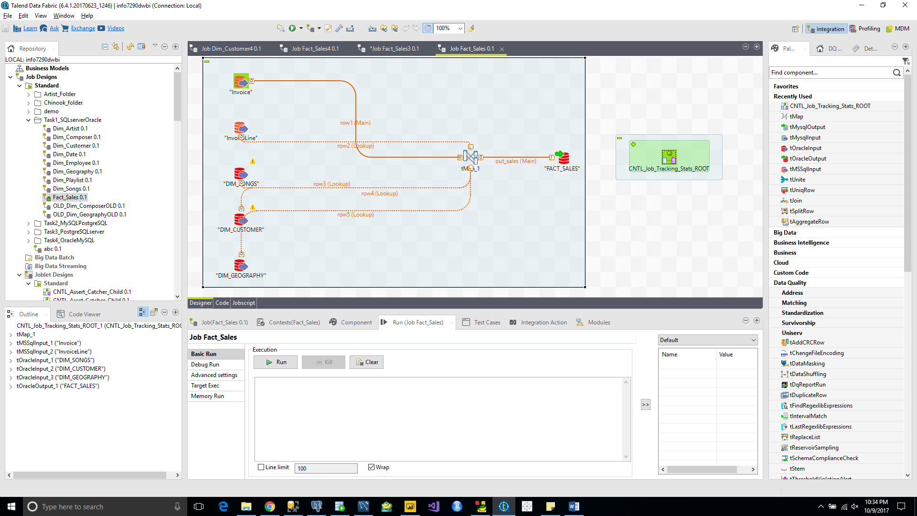

**TASK 2 MySQL to PostgreSQL**

Dim_Date

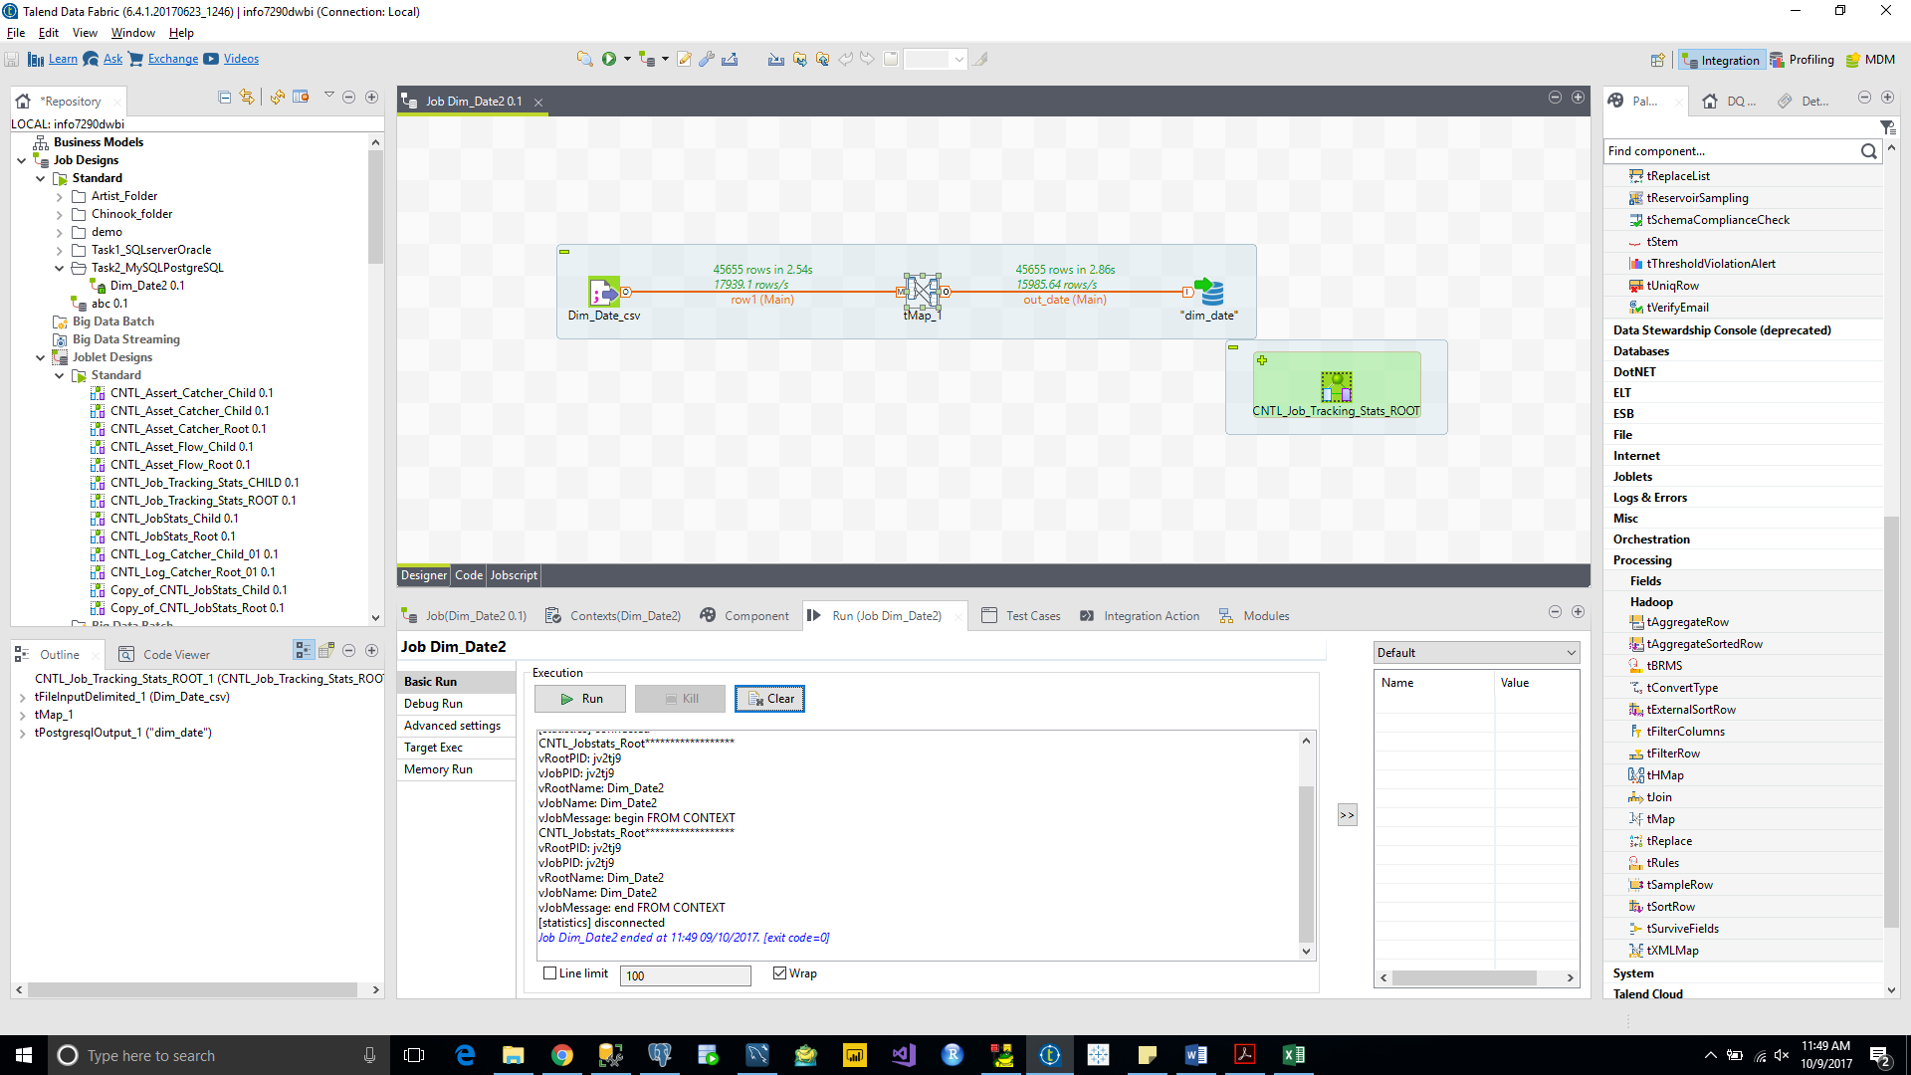

Dim_Artist

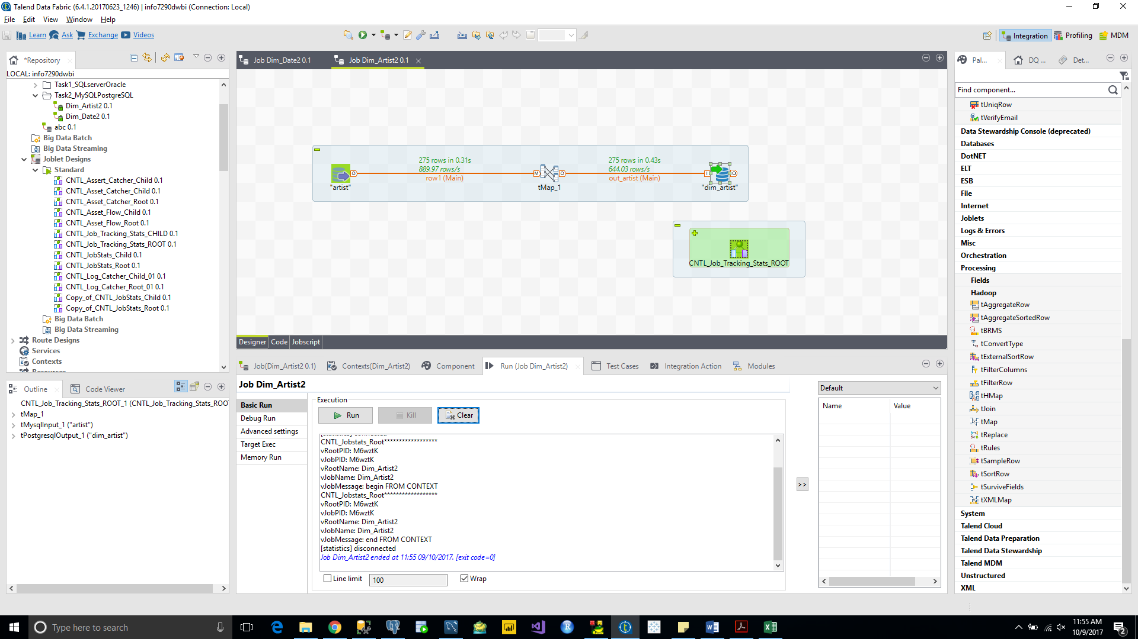

Dim_Composer

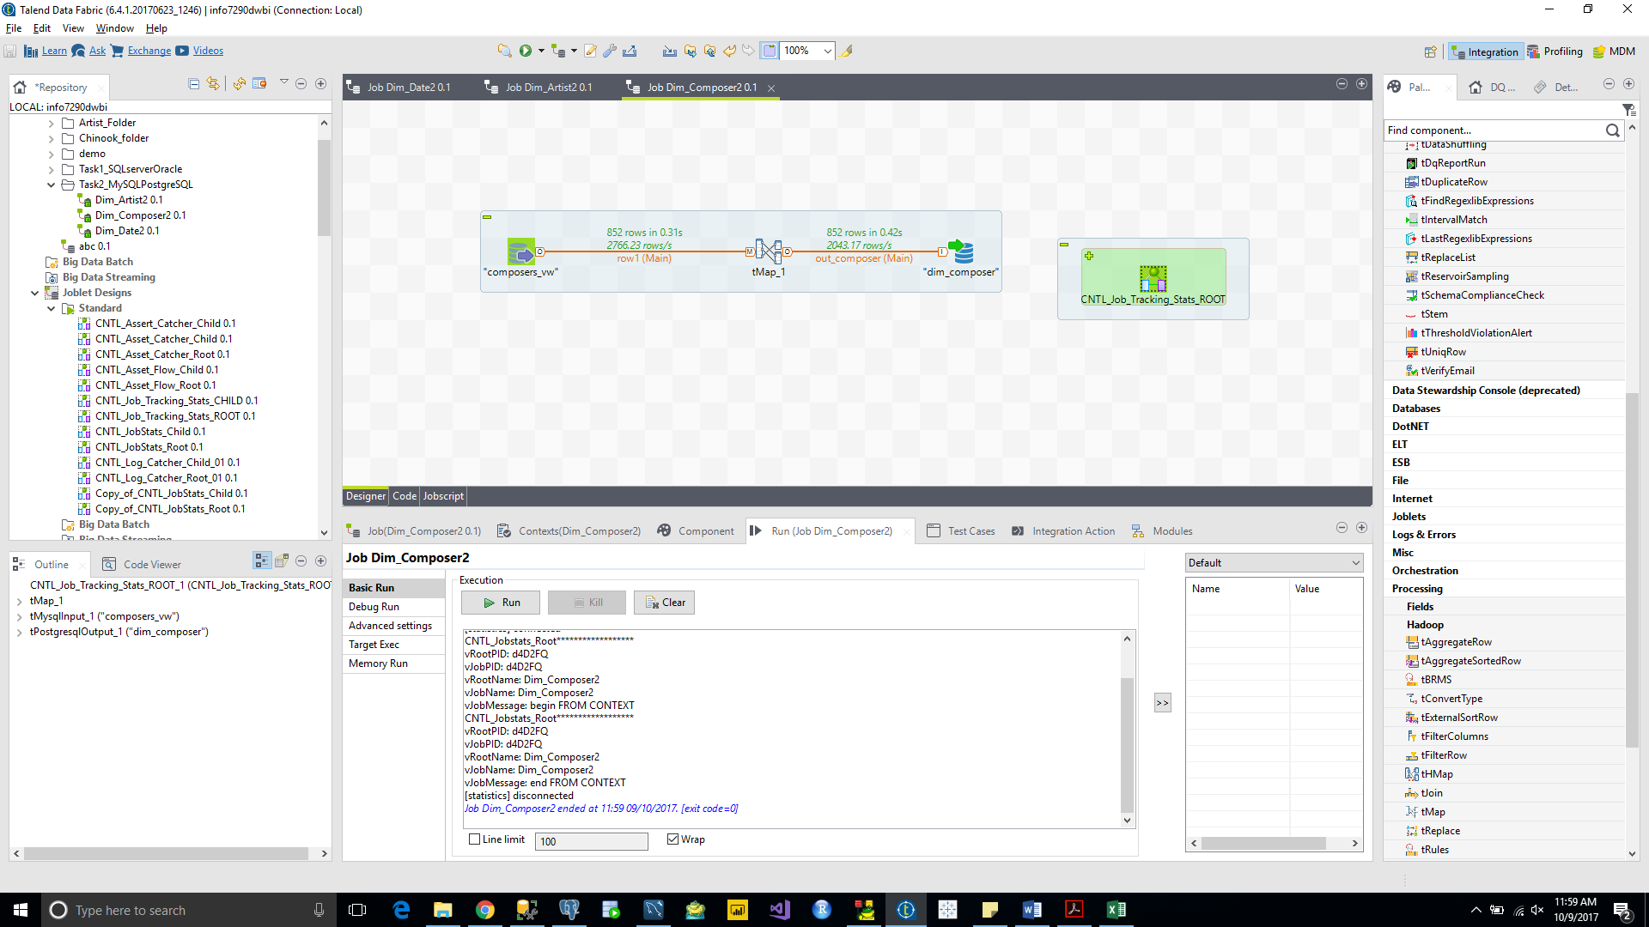

Dim_Songs

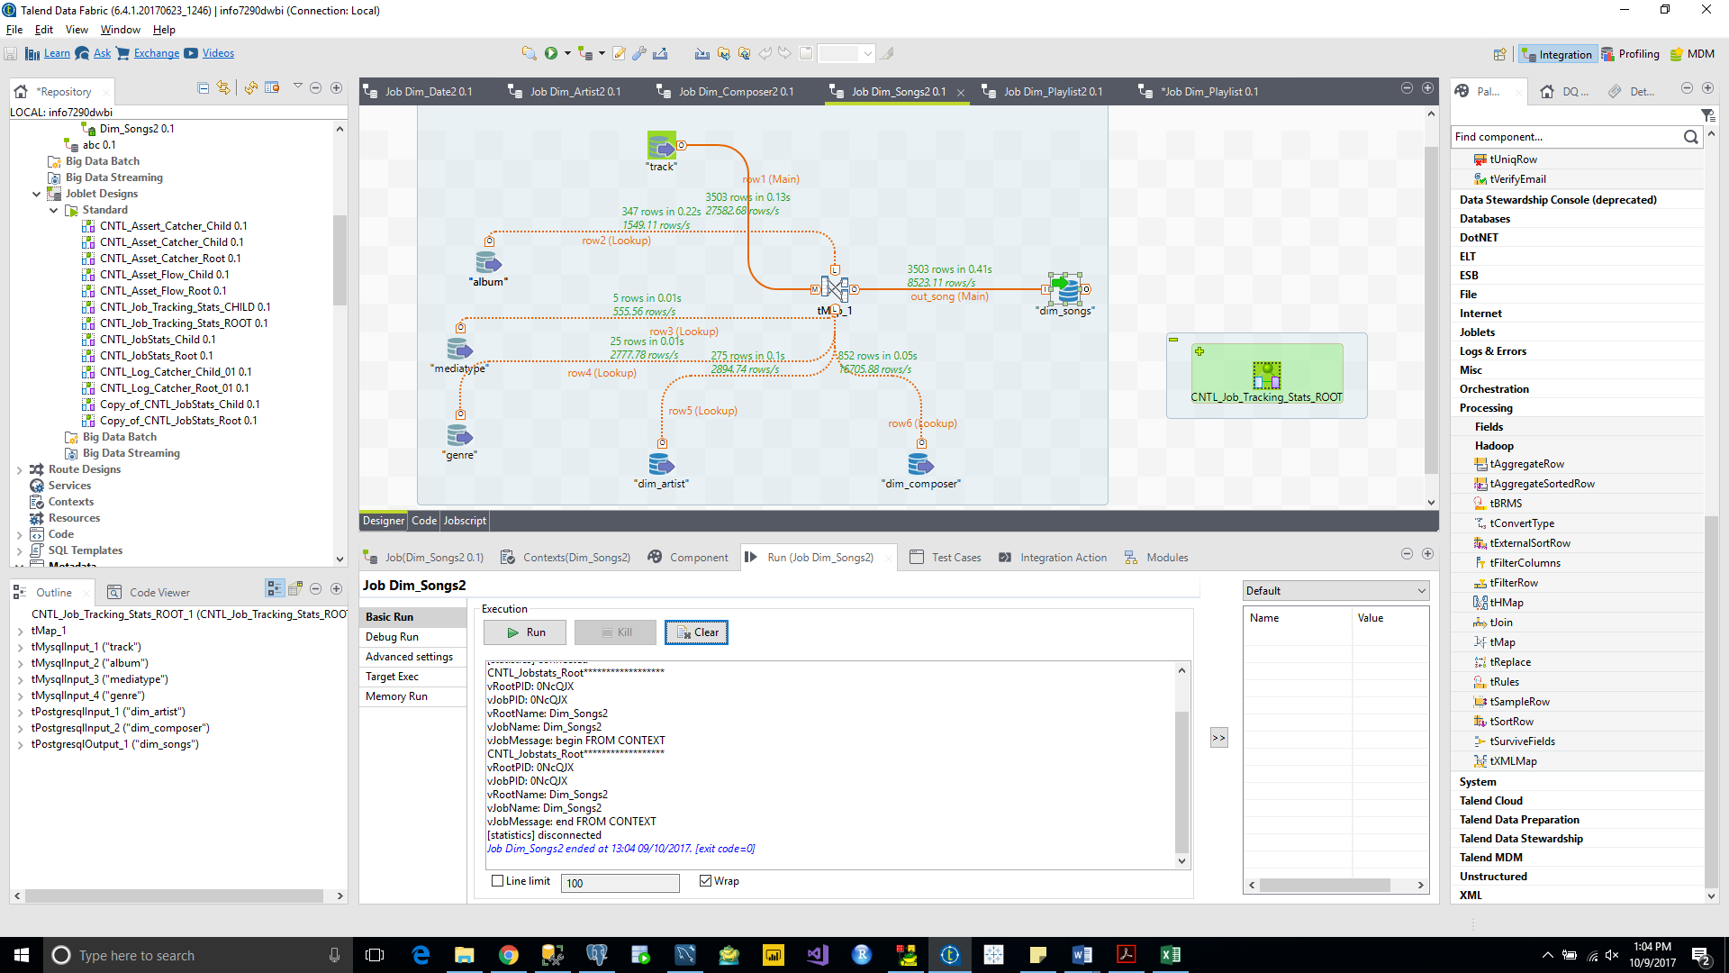

Dim_Playlist

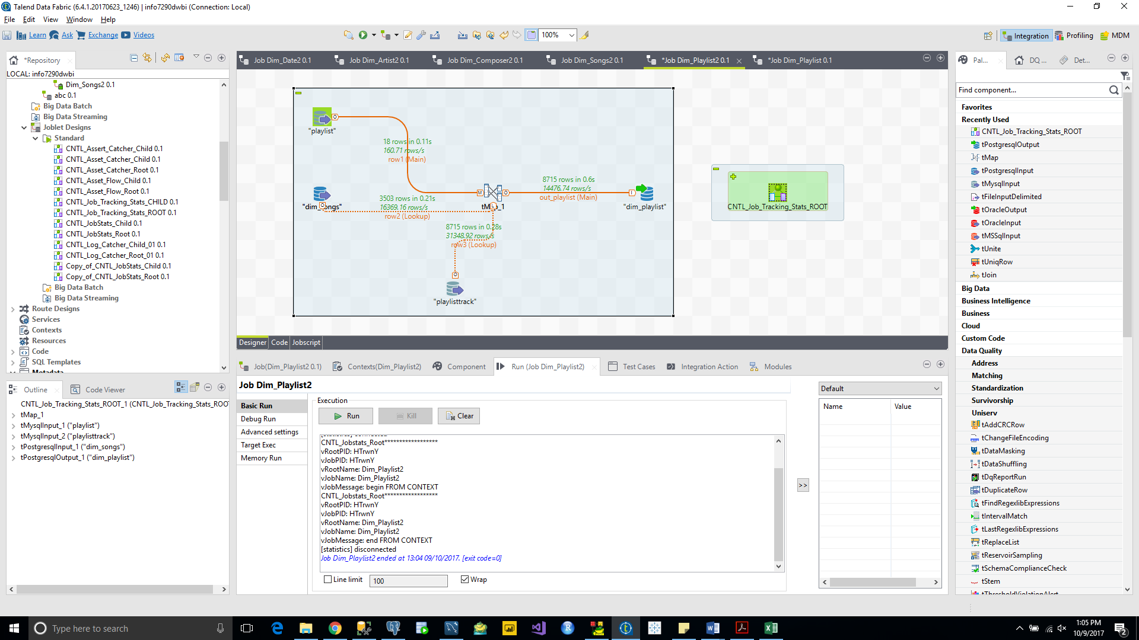

Dim_Geography

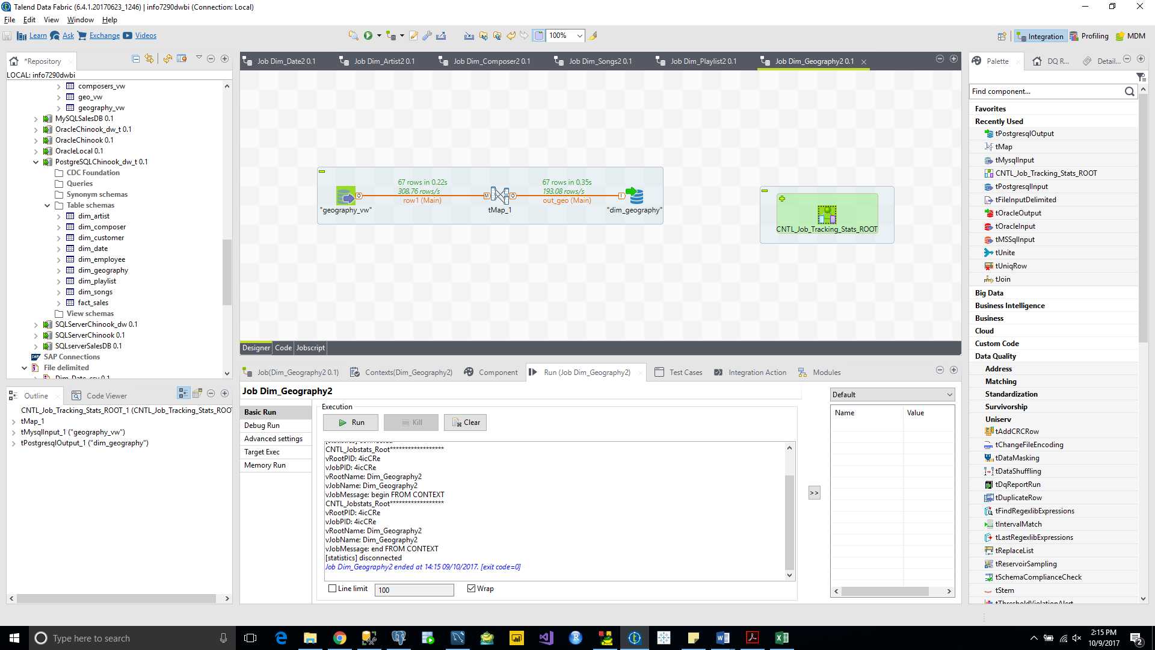

Dim_Employee

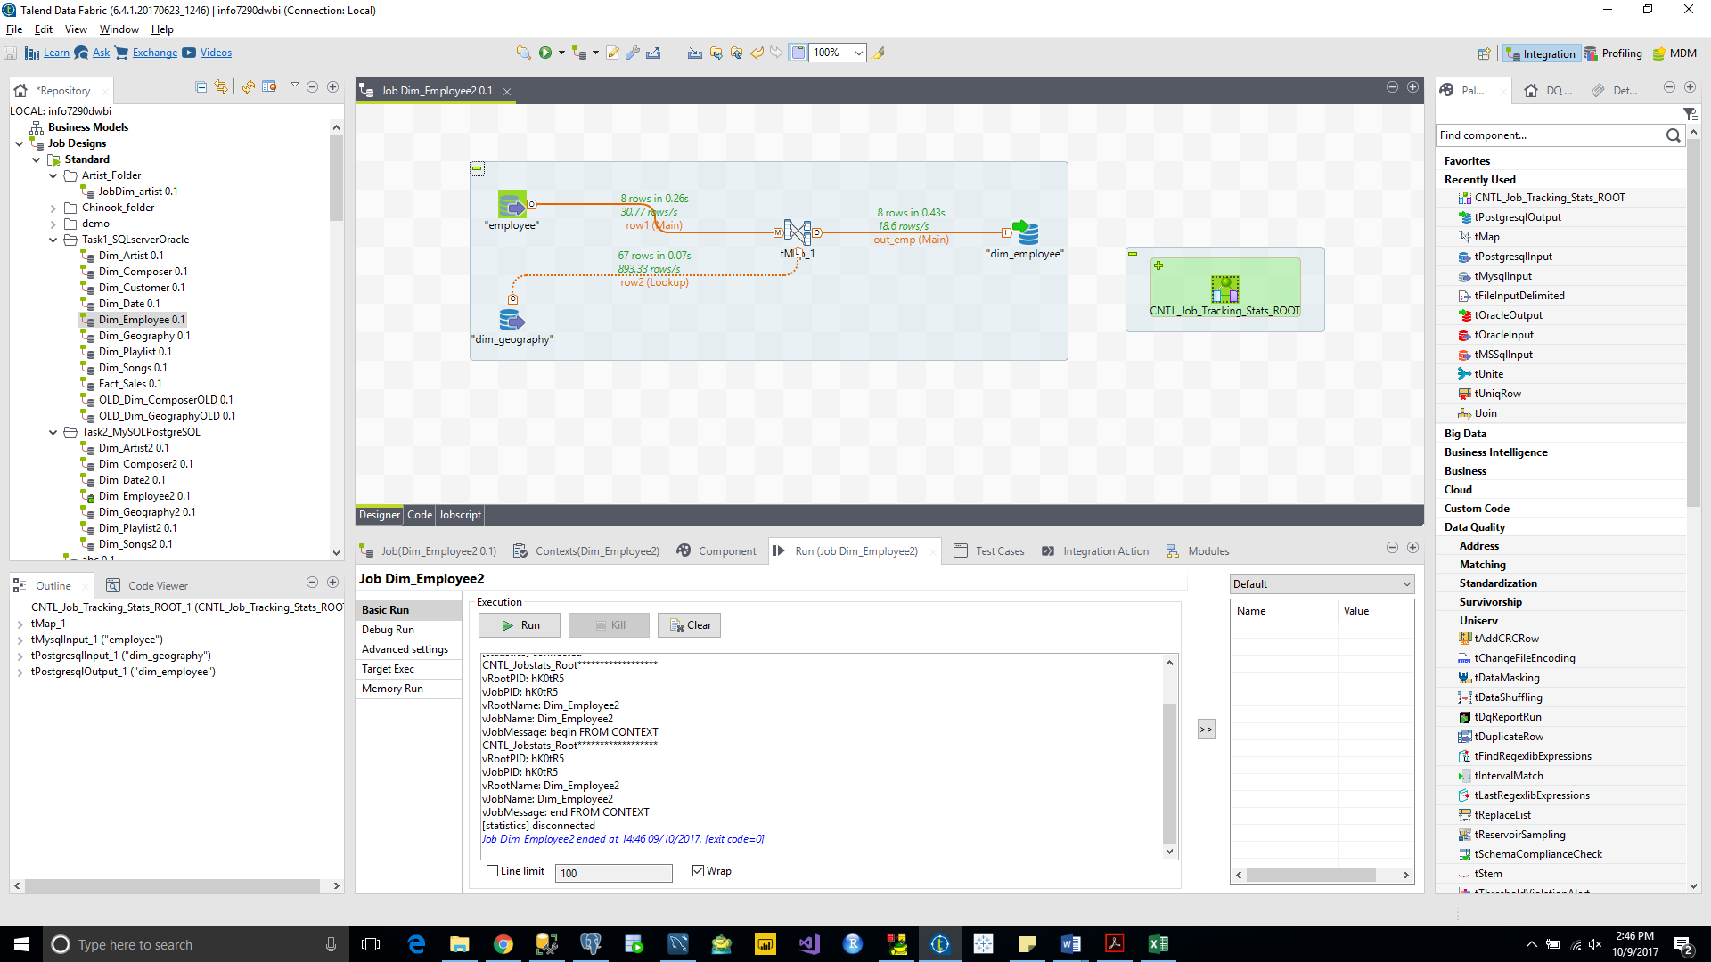

Dim_Customer

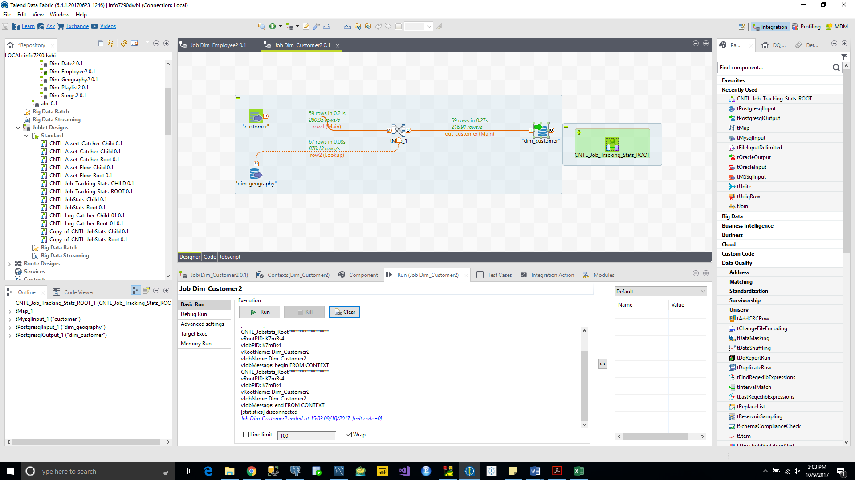

Fact_Sales

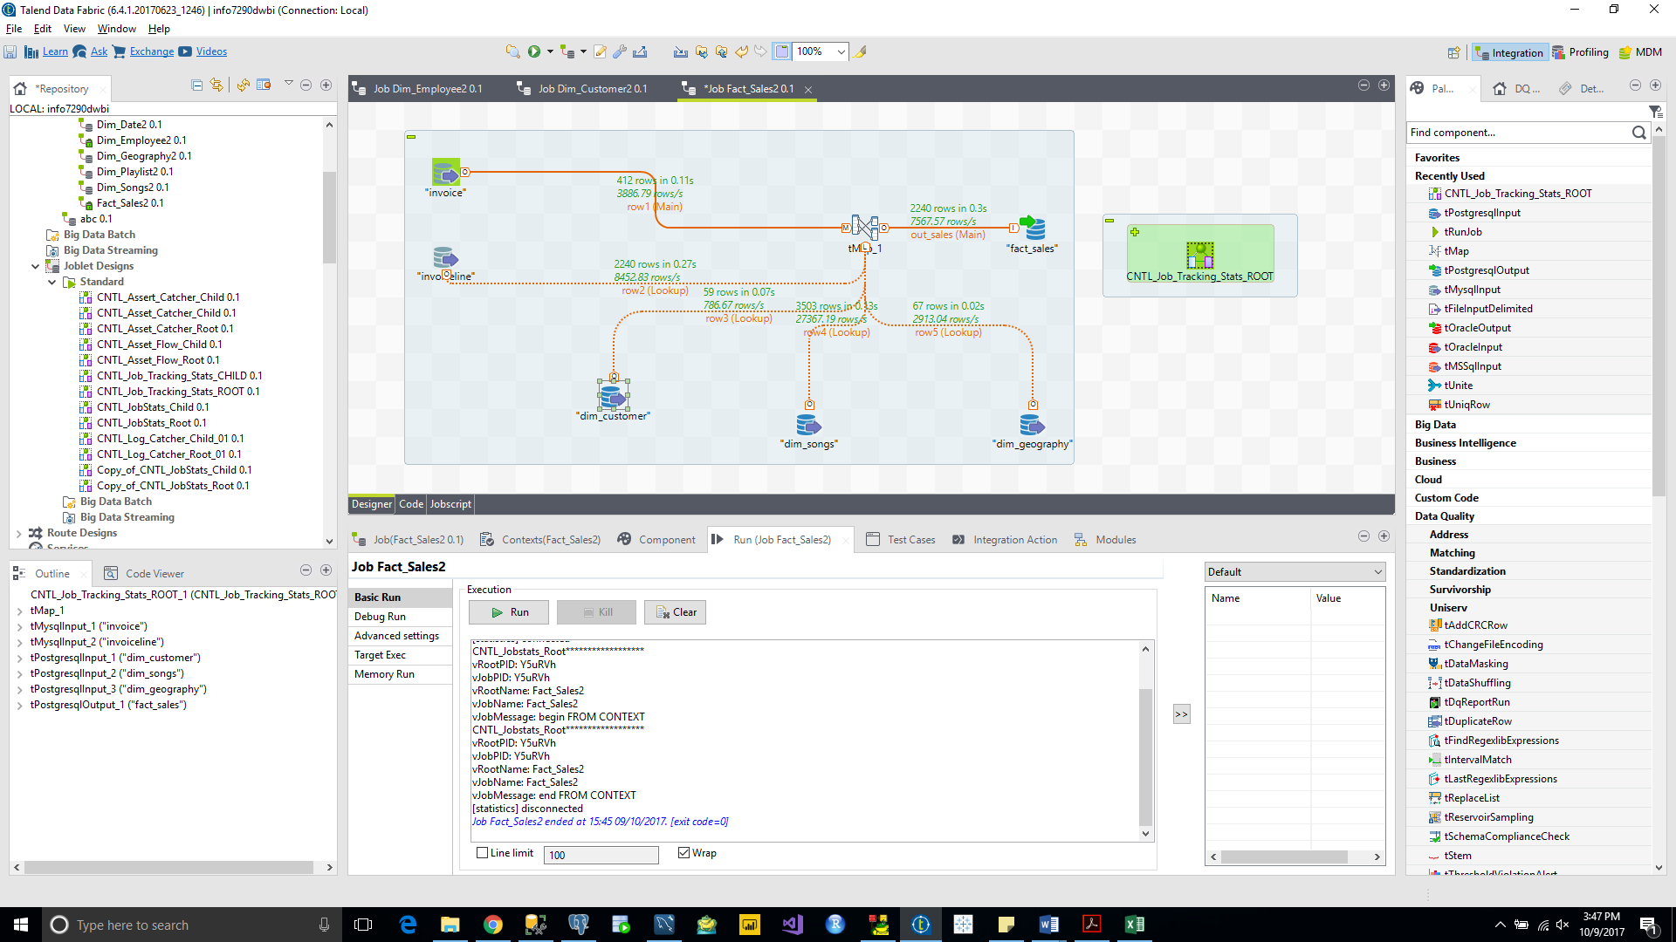

**TASK 3 PostgreSQL to SQL server**

Dim_Date

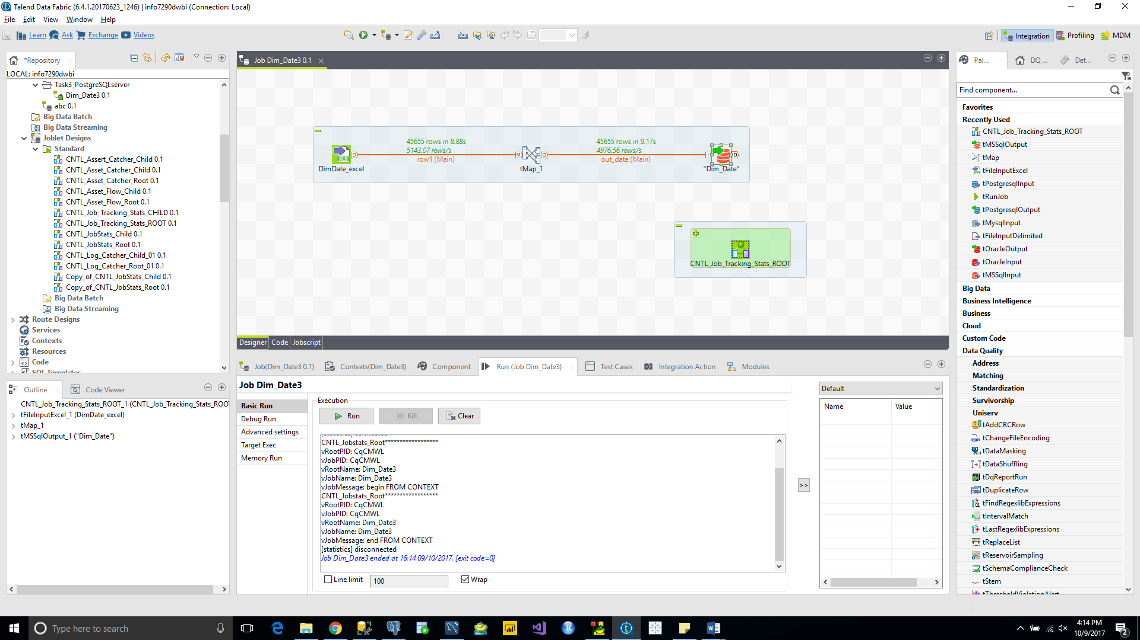

Dim_Artist

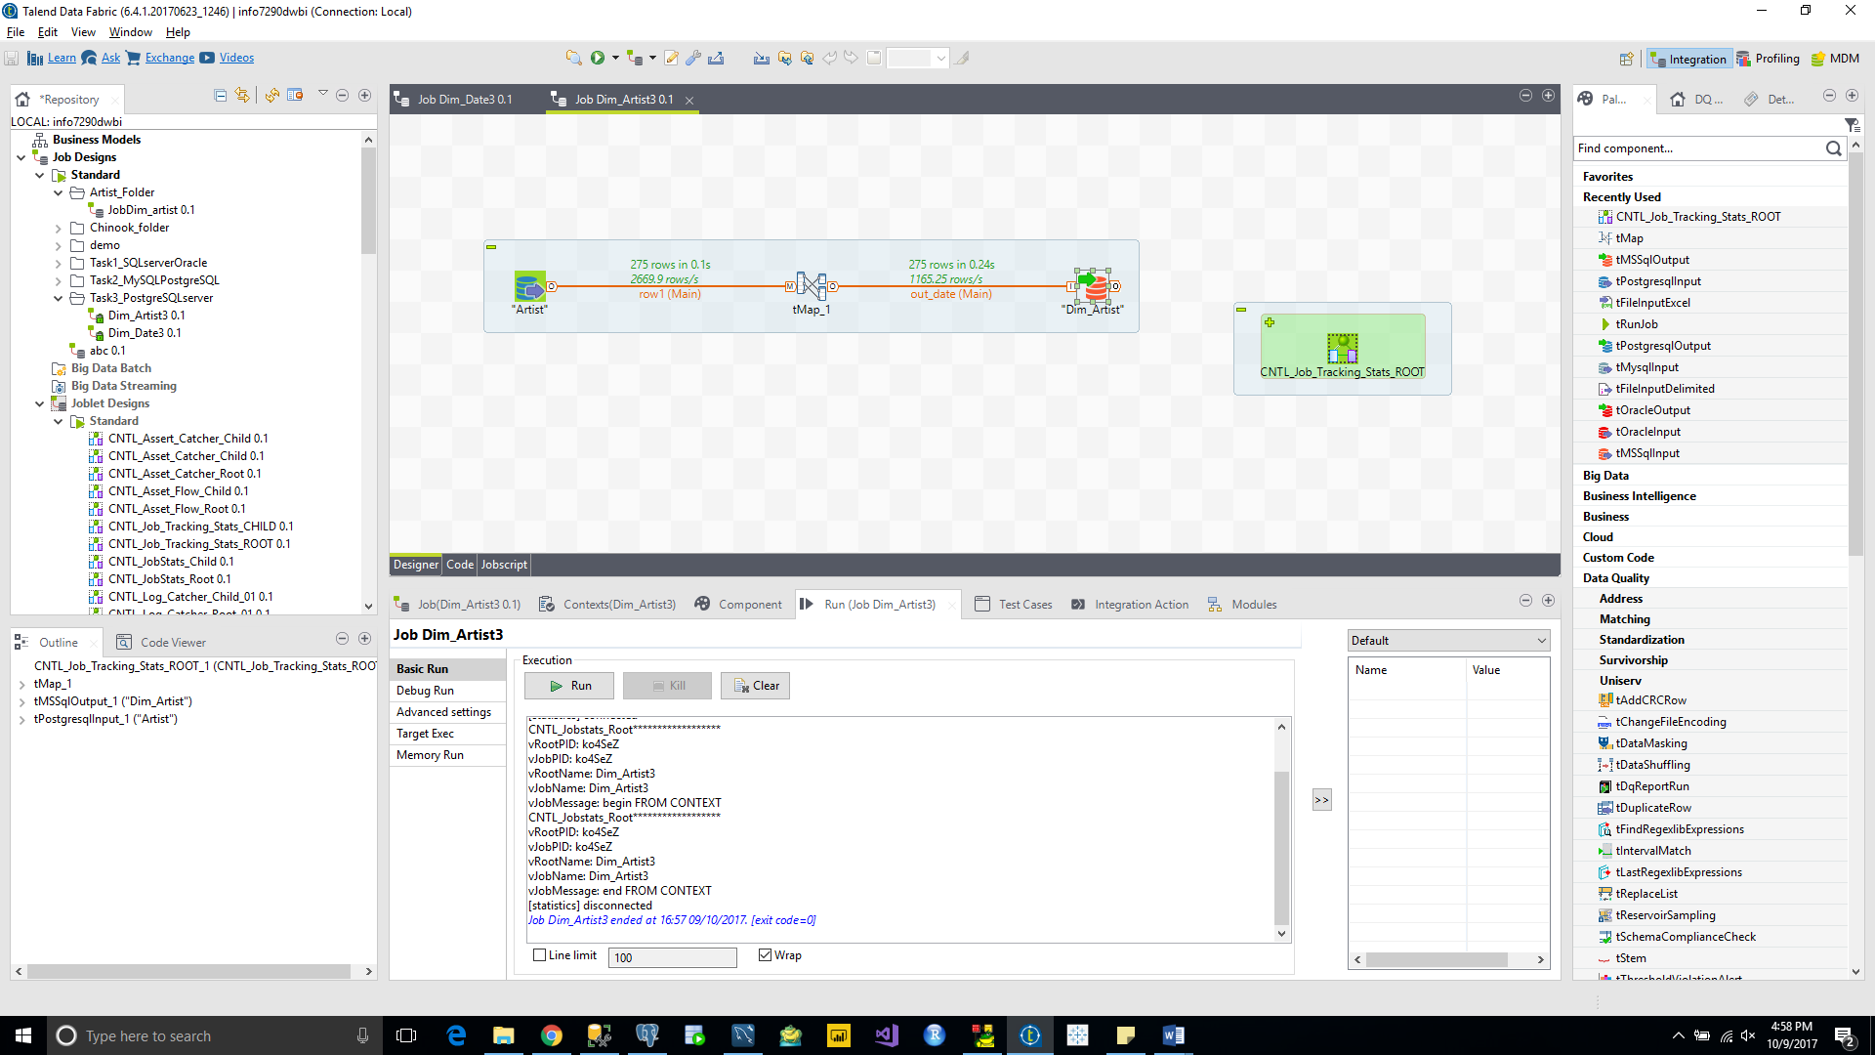

Dim_Composer

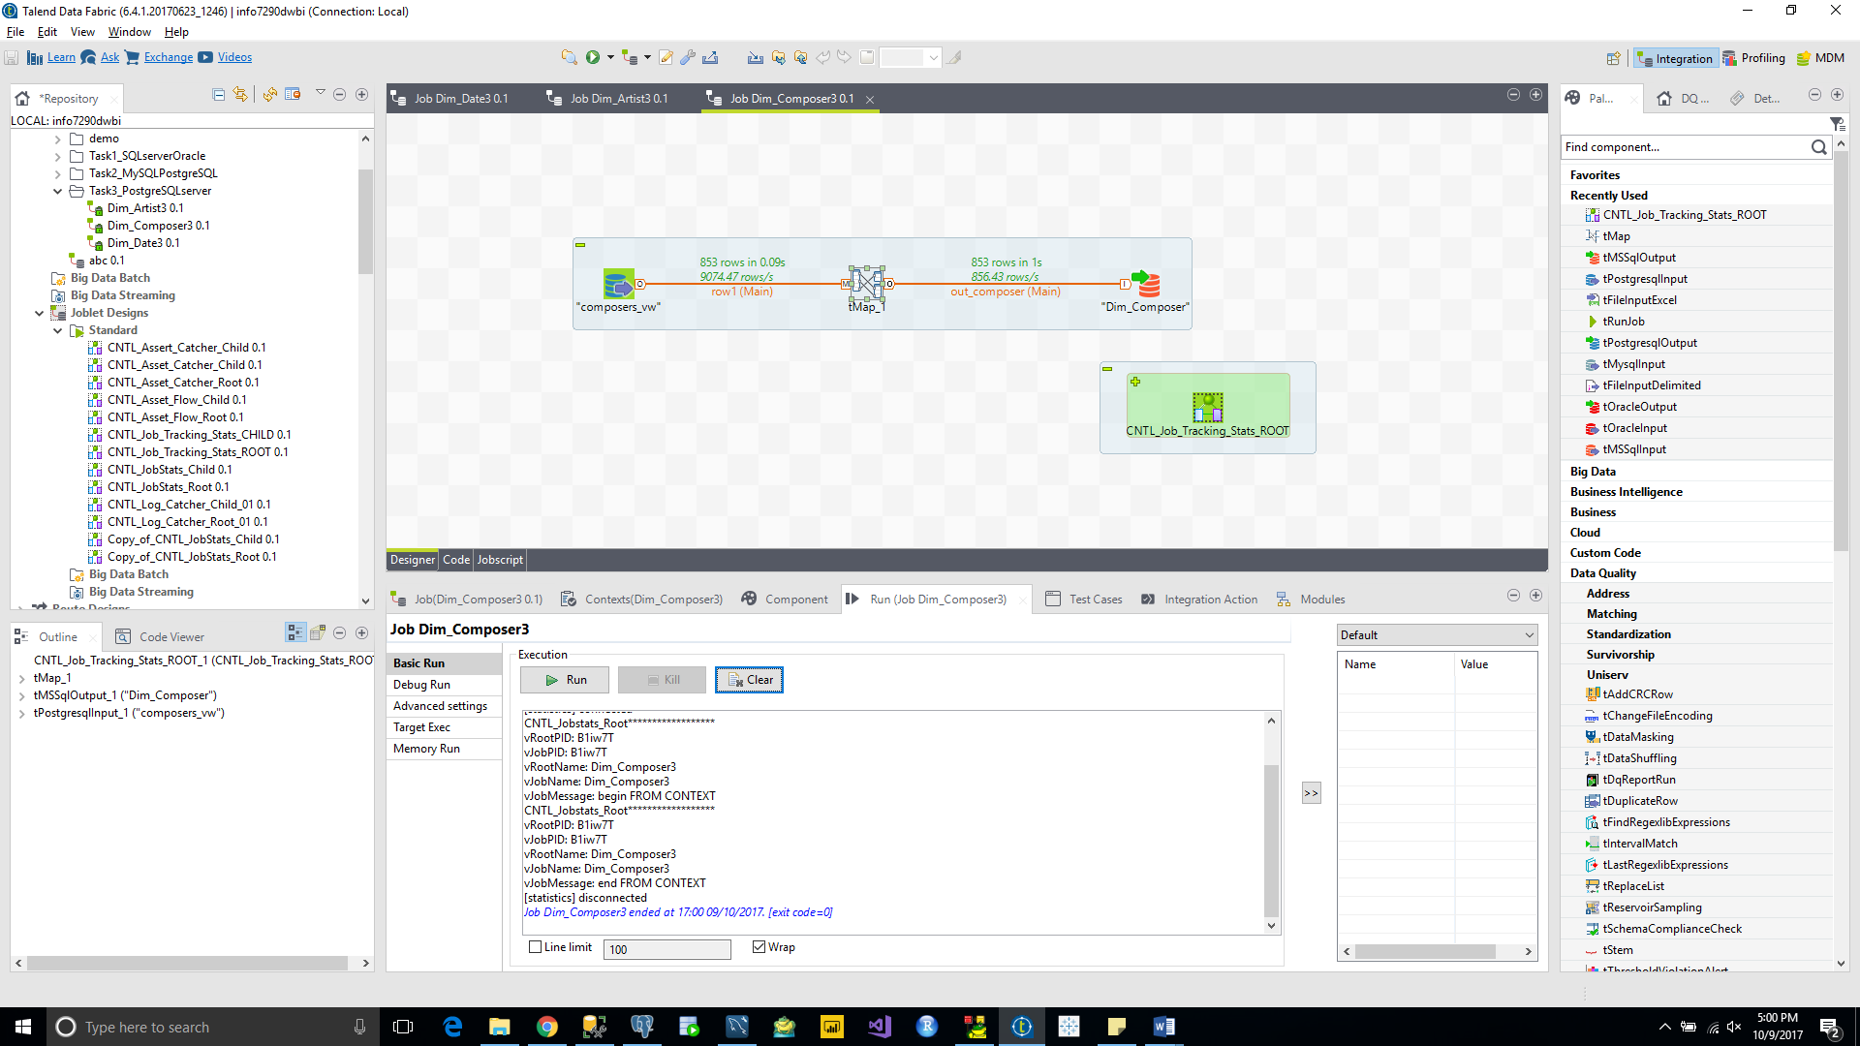

Dim_Songs

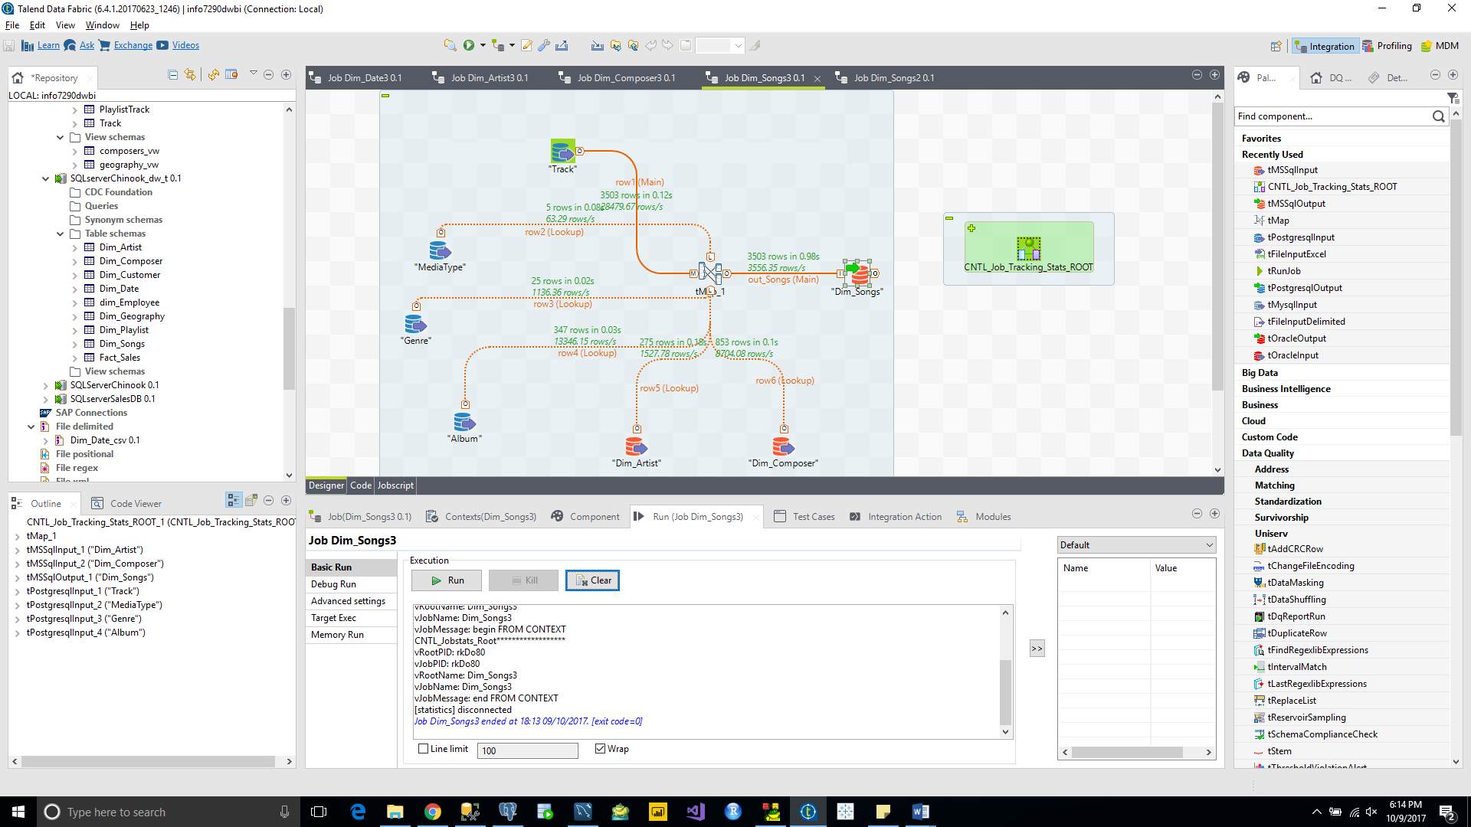

Dim_Geography

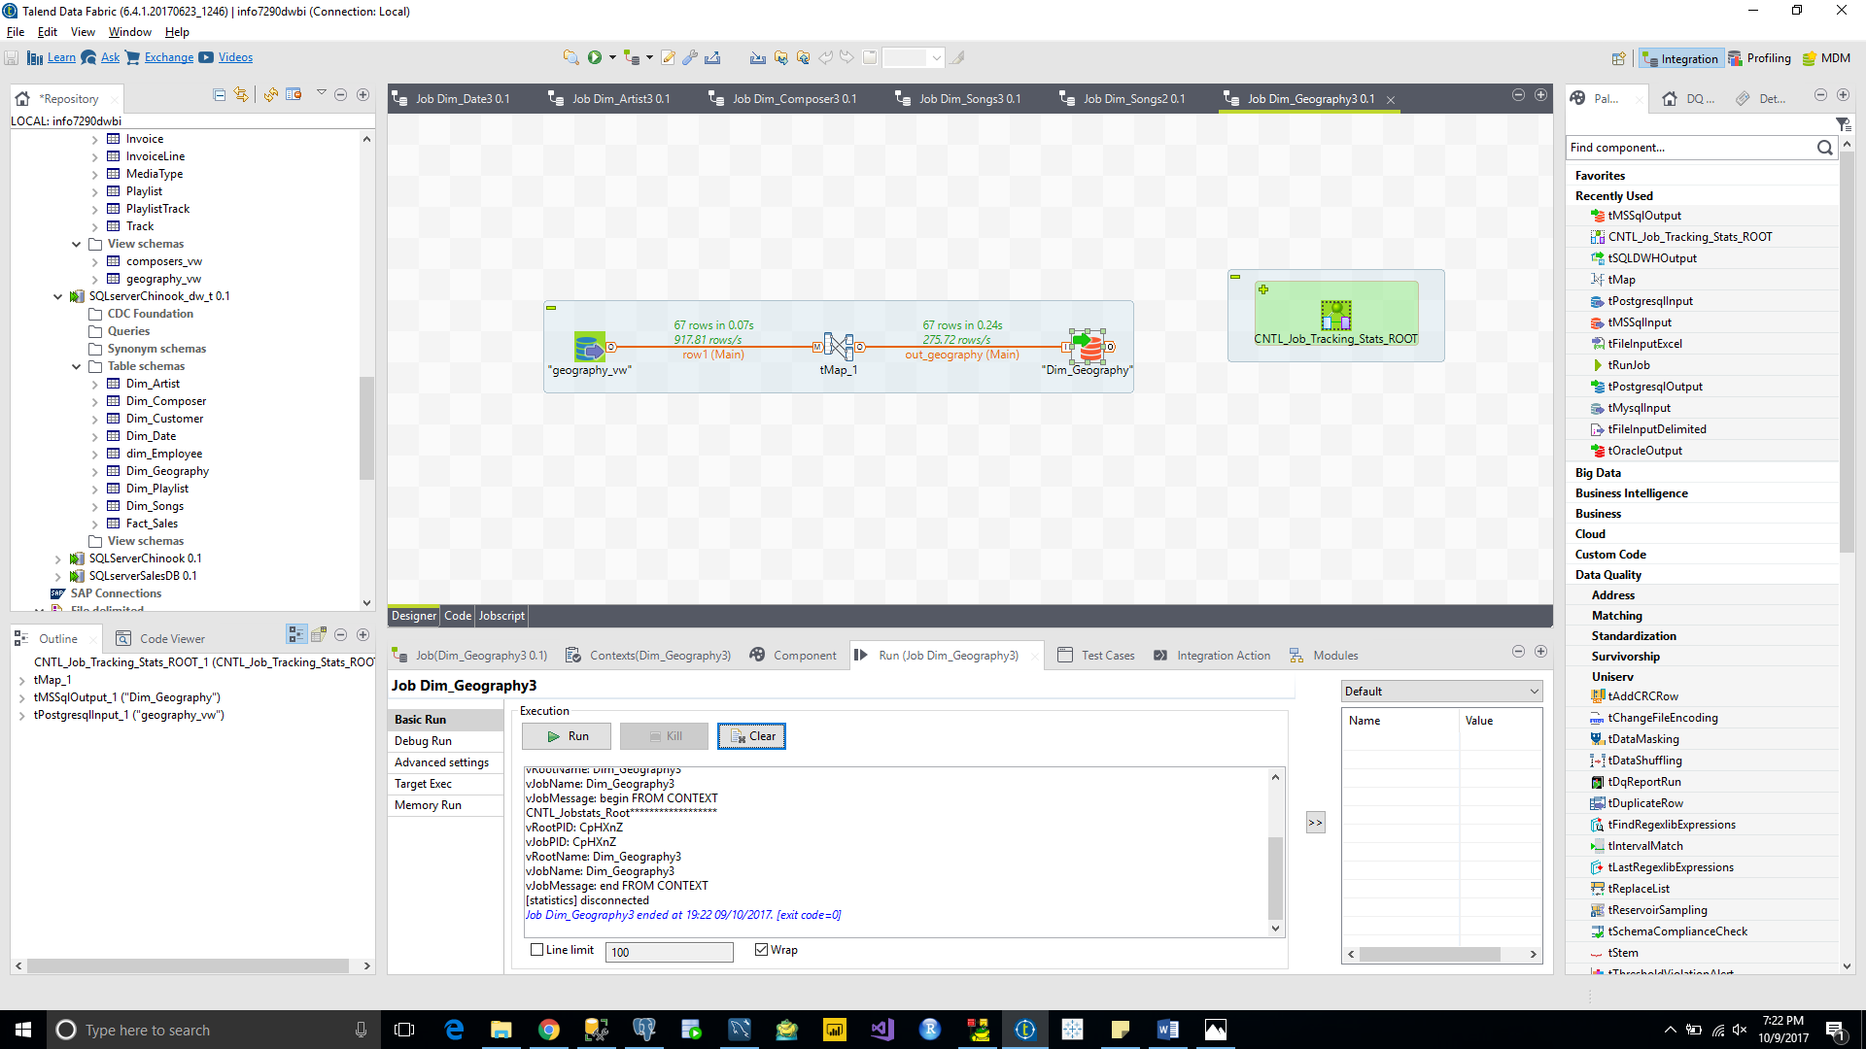

Dim_Playlist

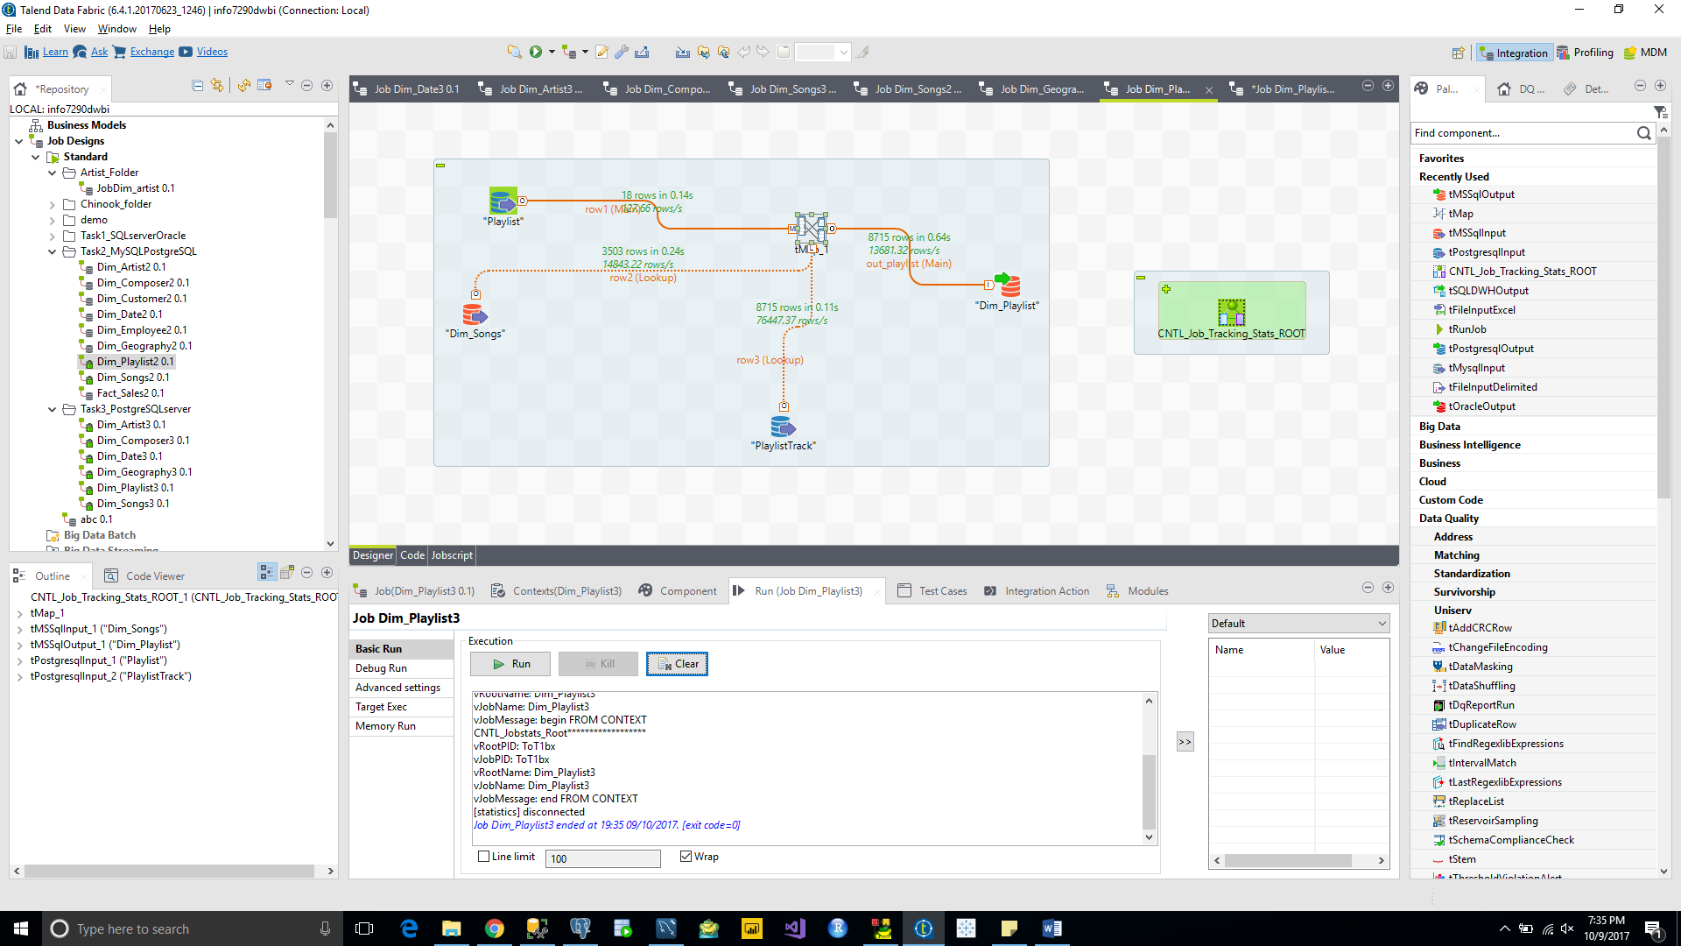

Dim_Employee

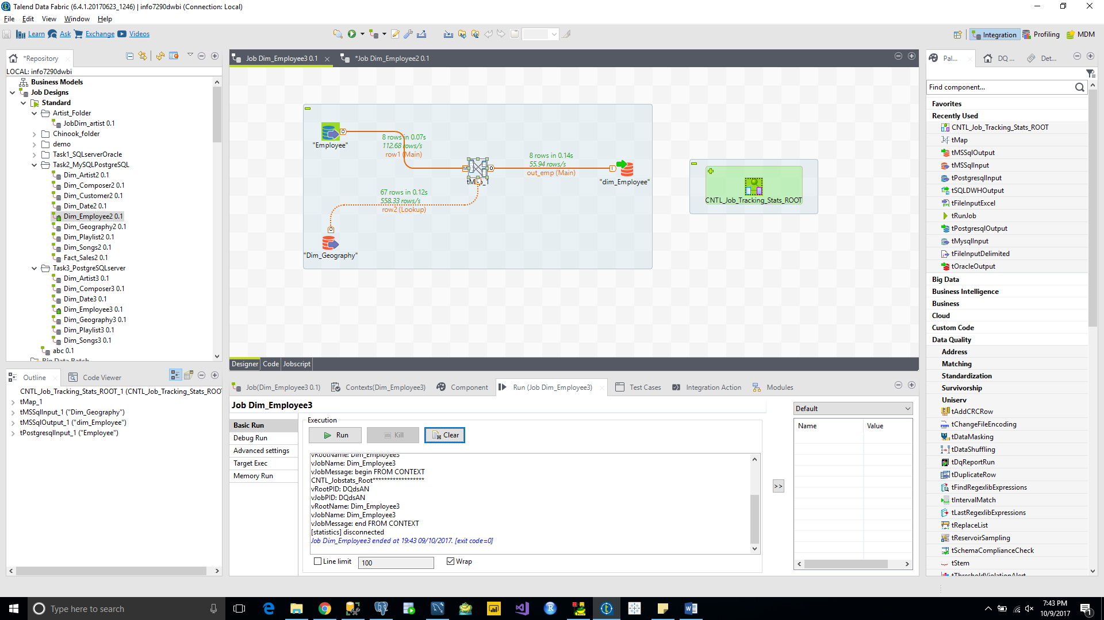

Dim_Customer

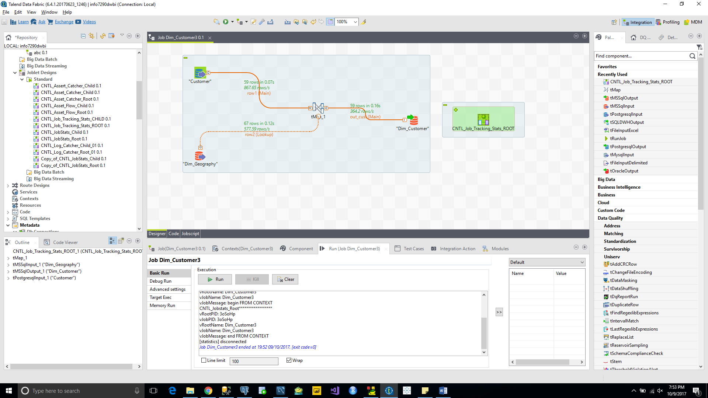

Fact_Sales

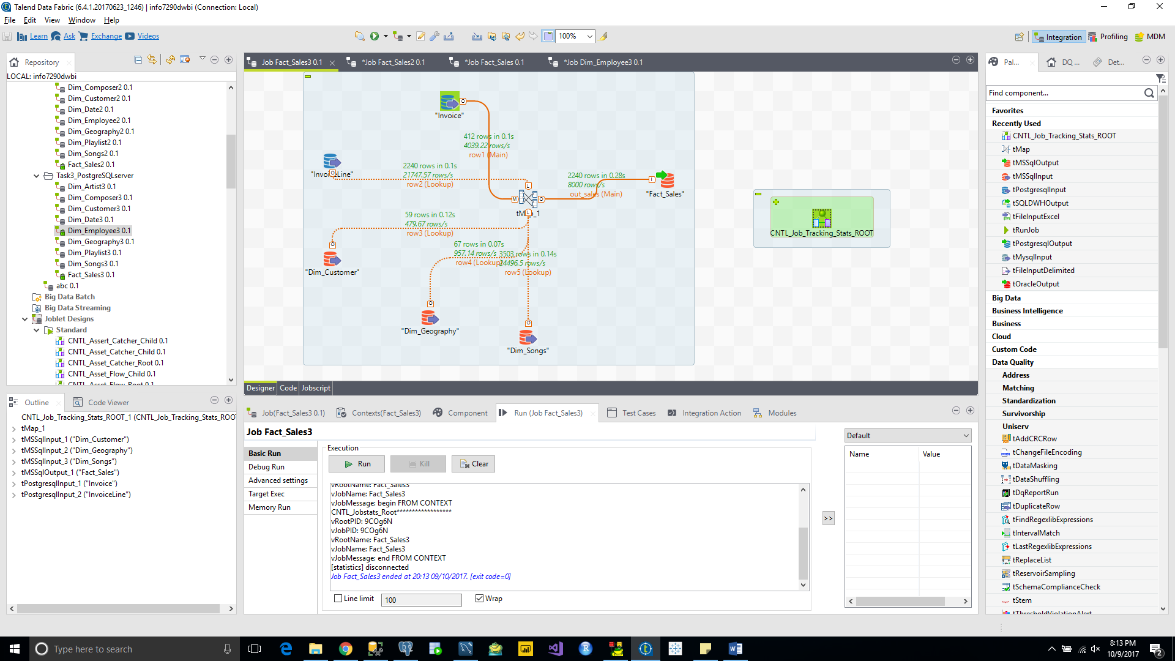

**TASK 4 Oracle to MySQL**

Dim_Date

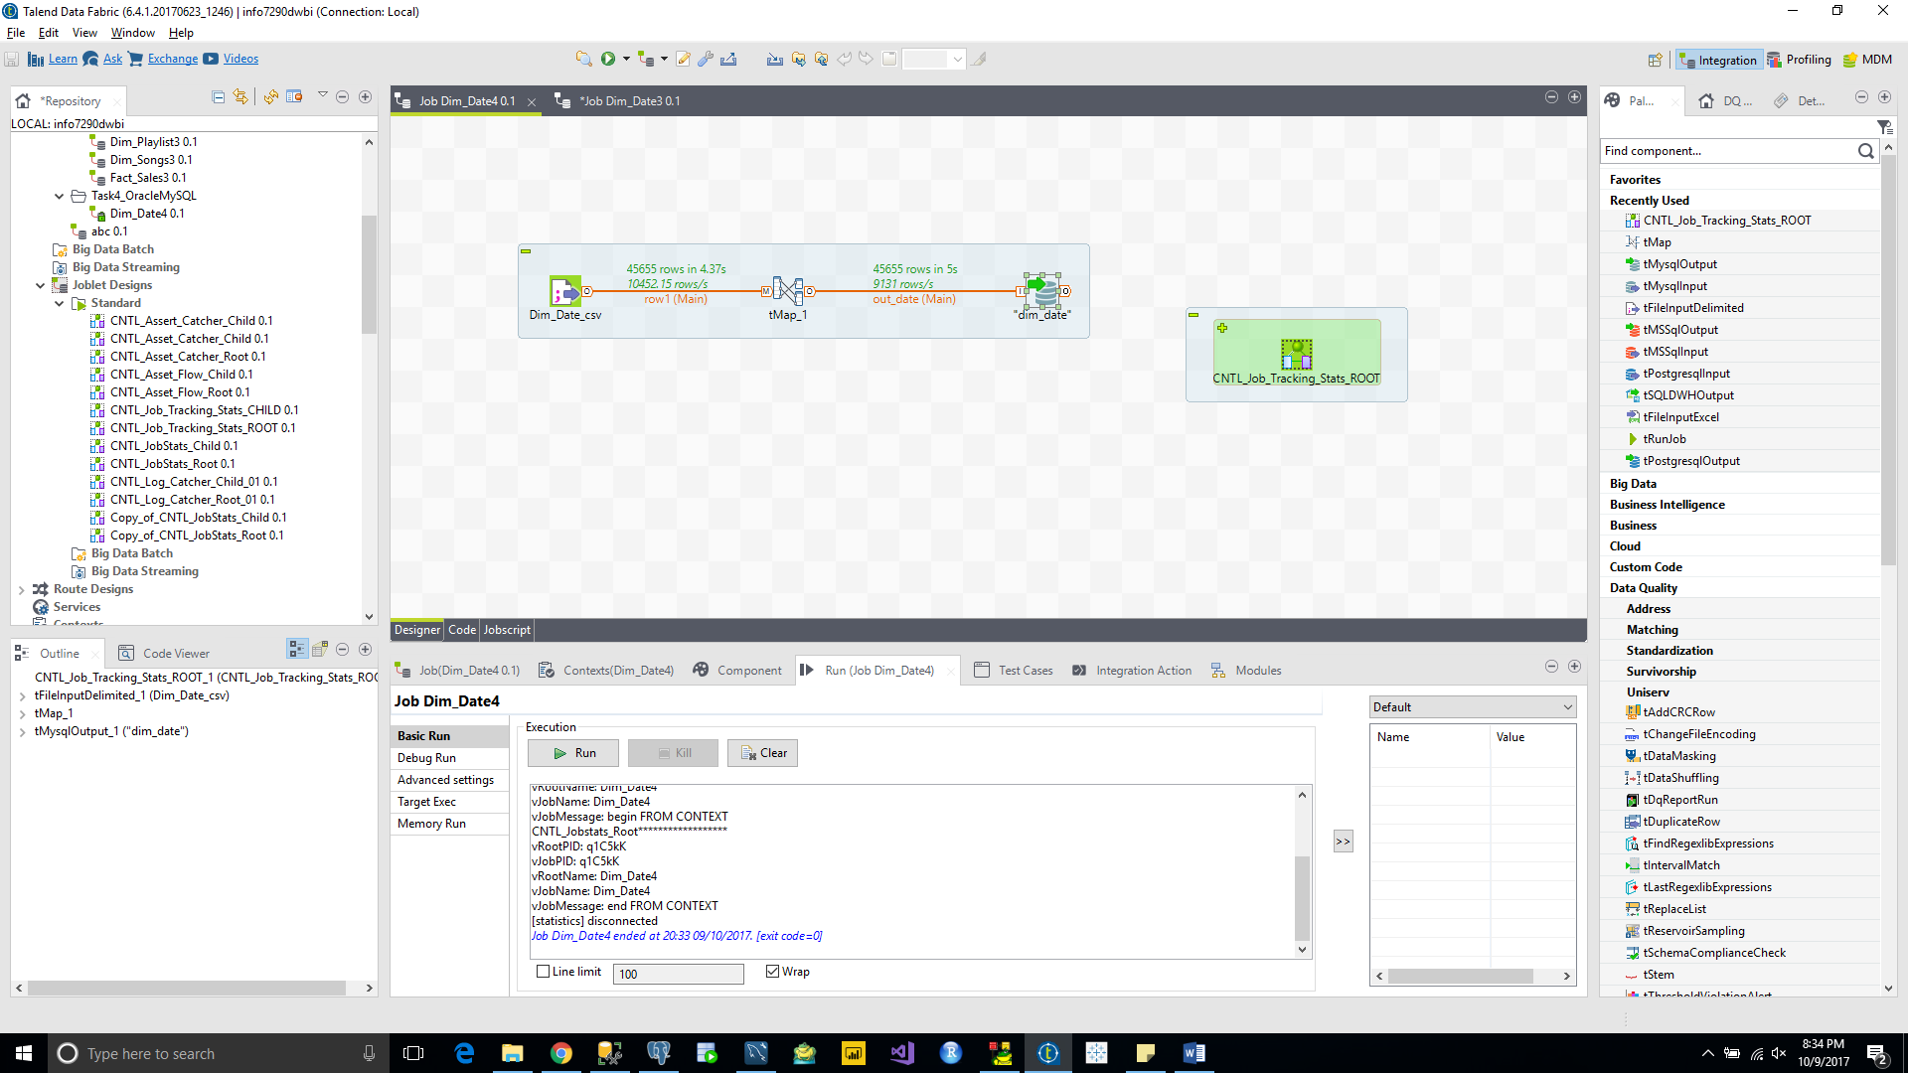

Dim_Artist

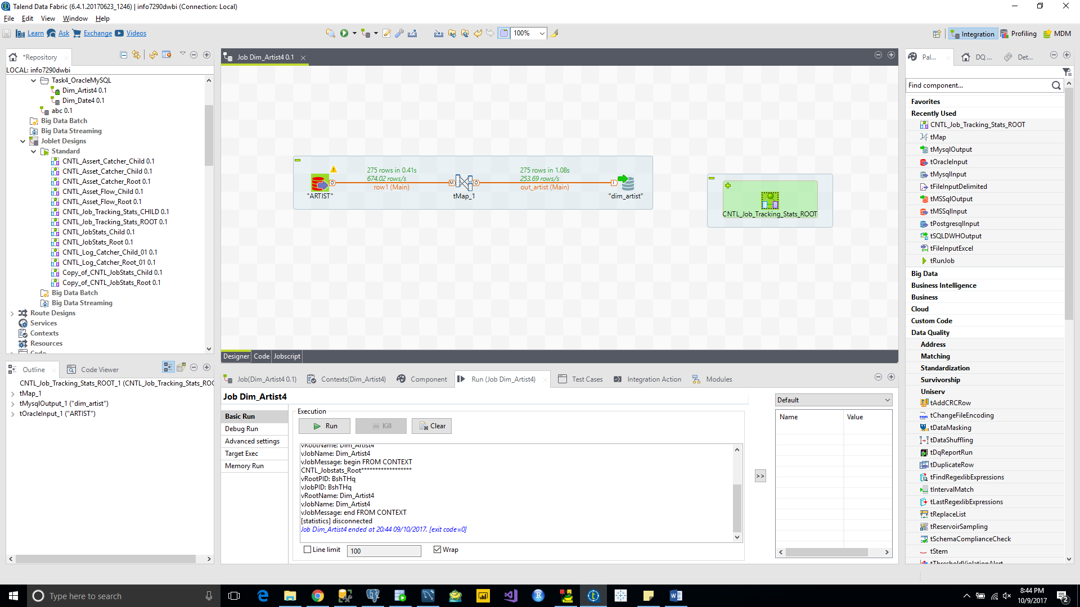

Dim_Composer

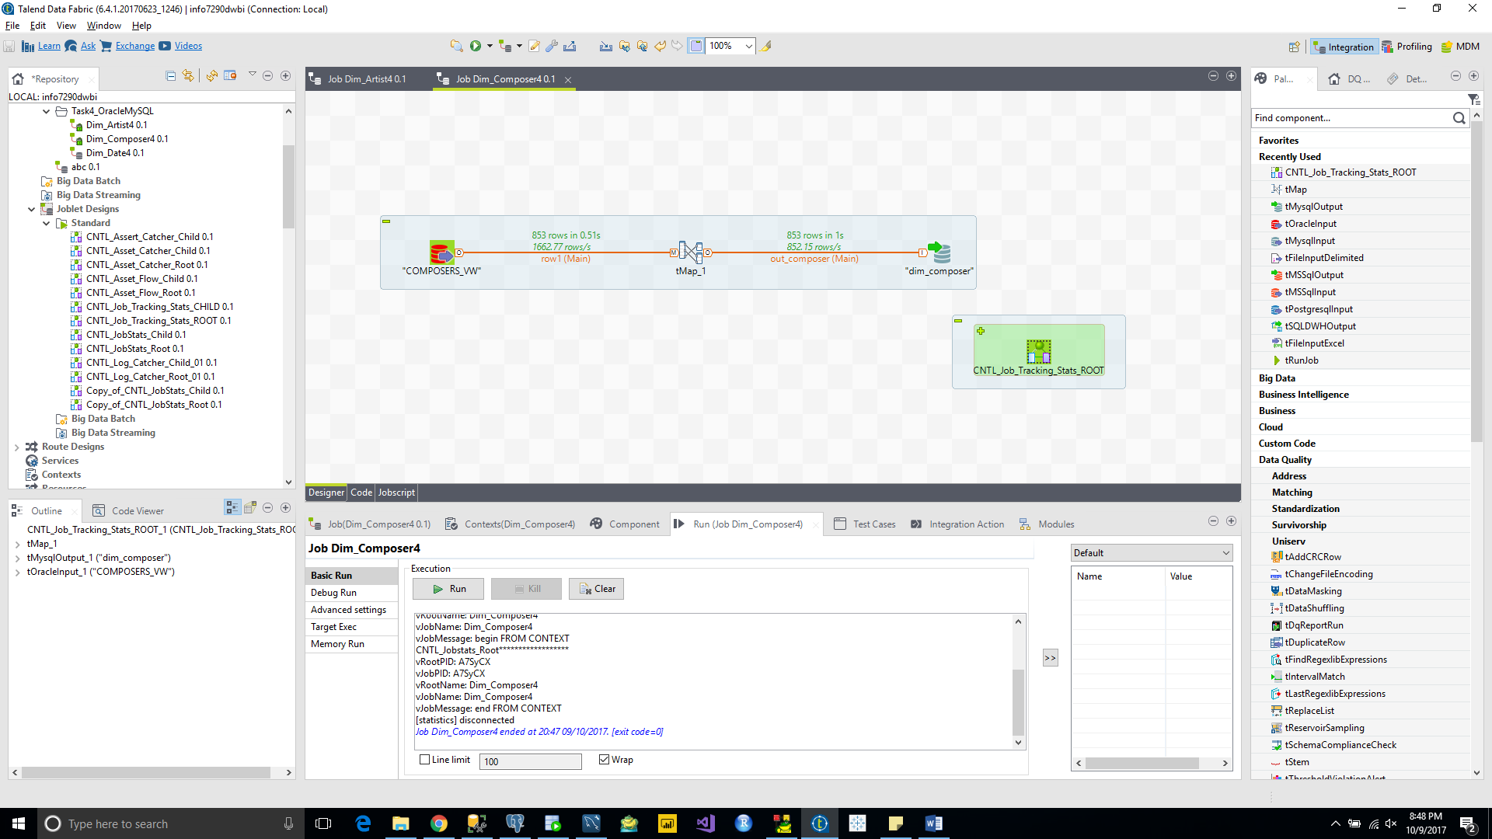

Dim_Songs

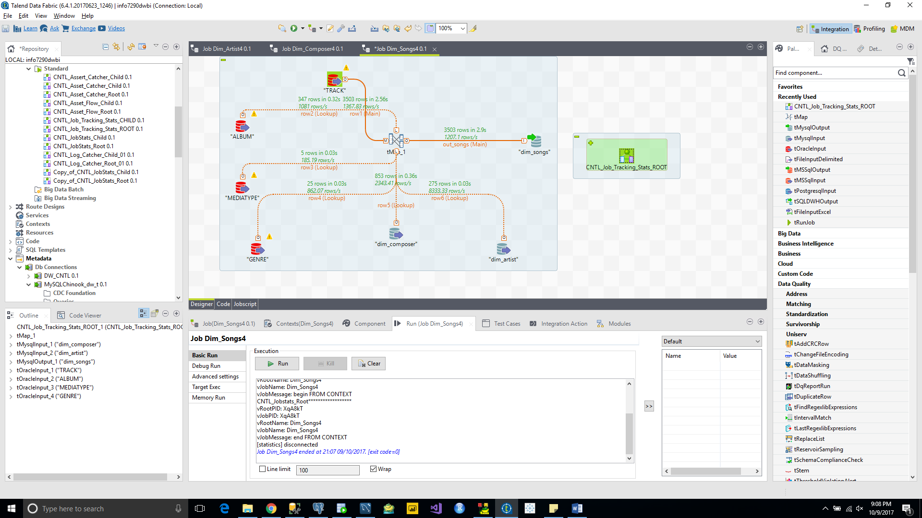

Dim_Playlist

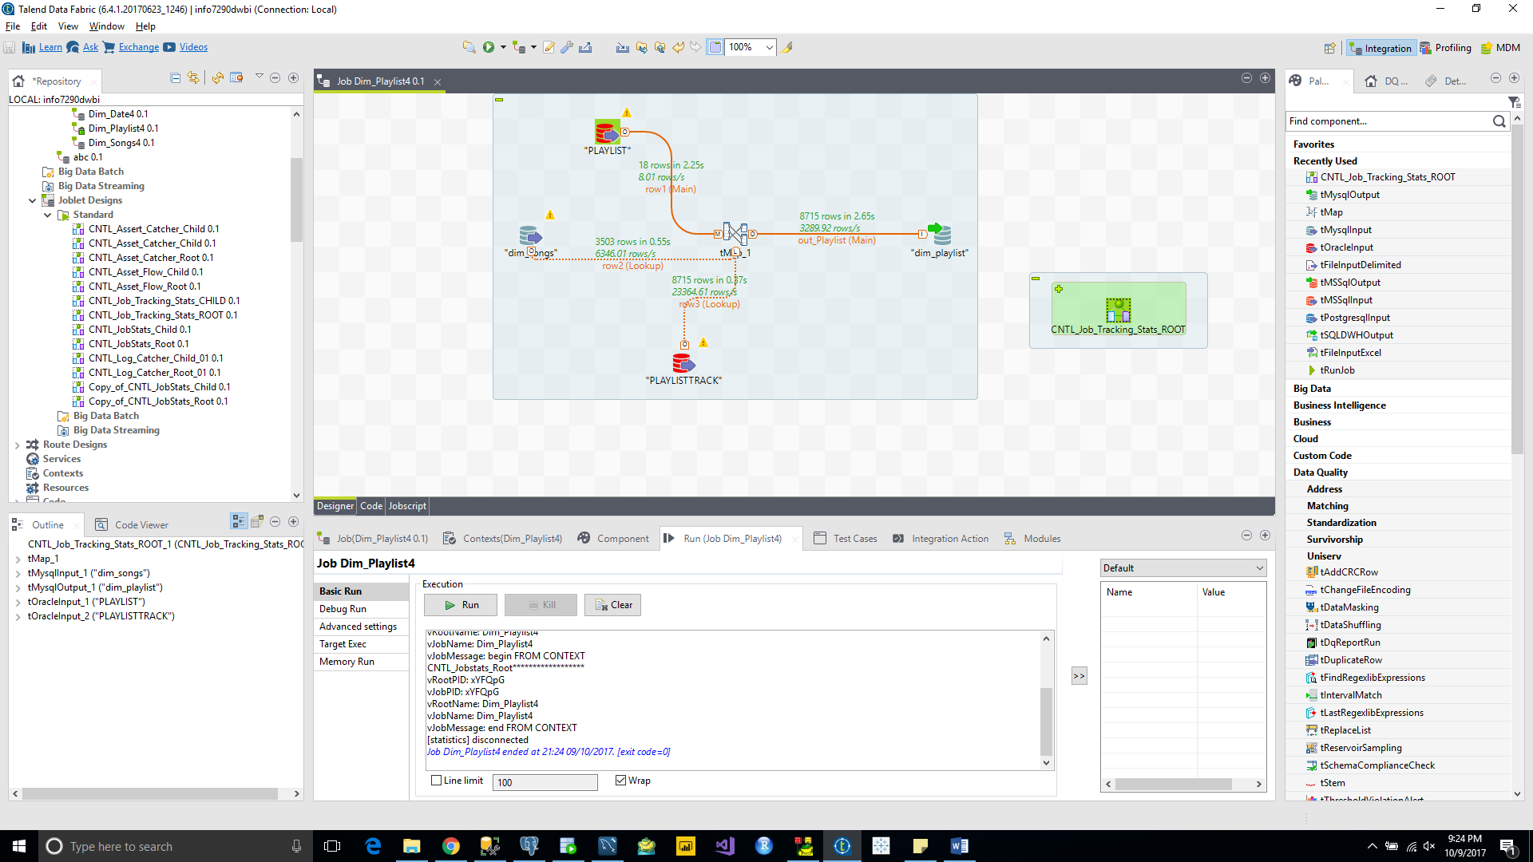

Dim_Geography

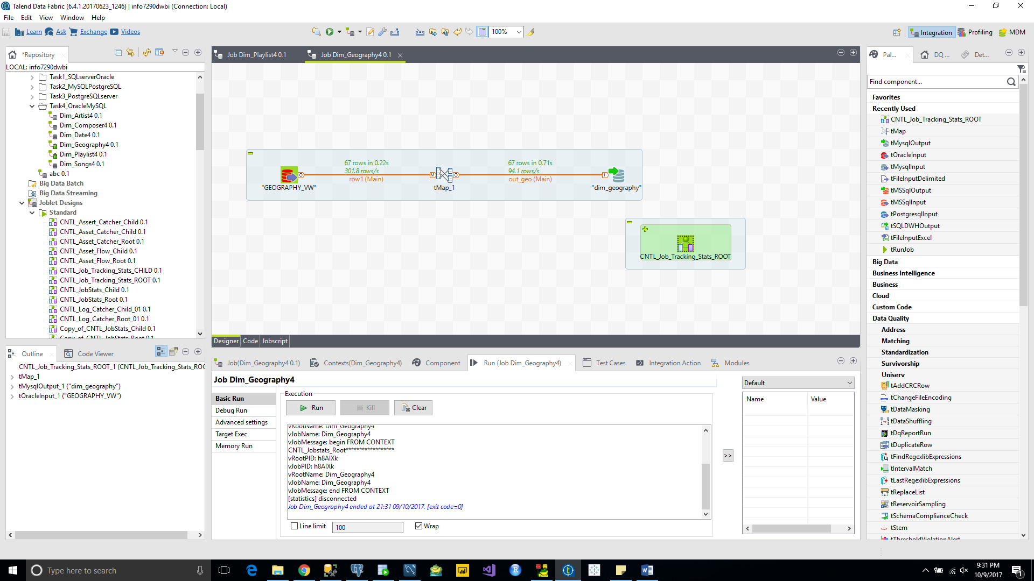

Dim_Employee

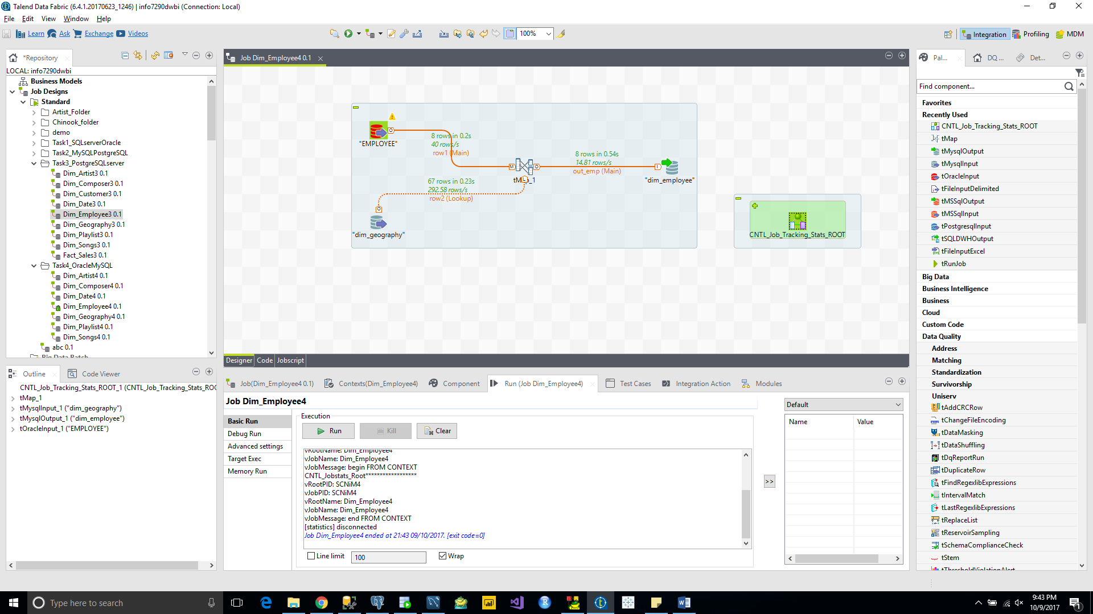

Dim_Customer

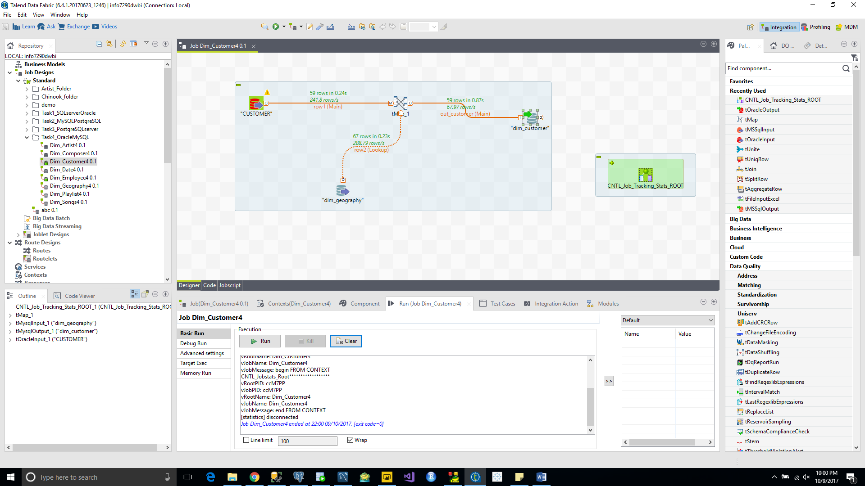

Fact_Sales

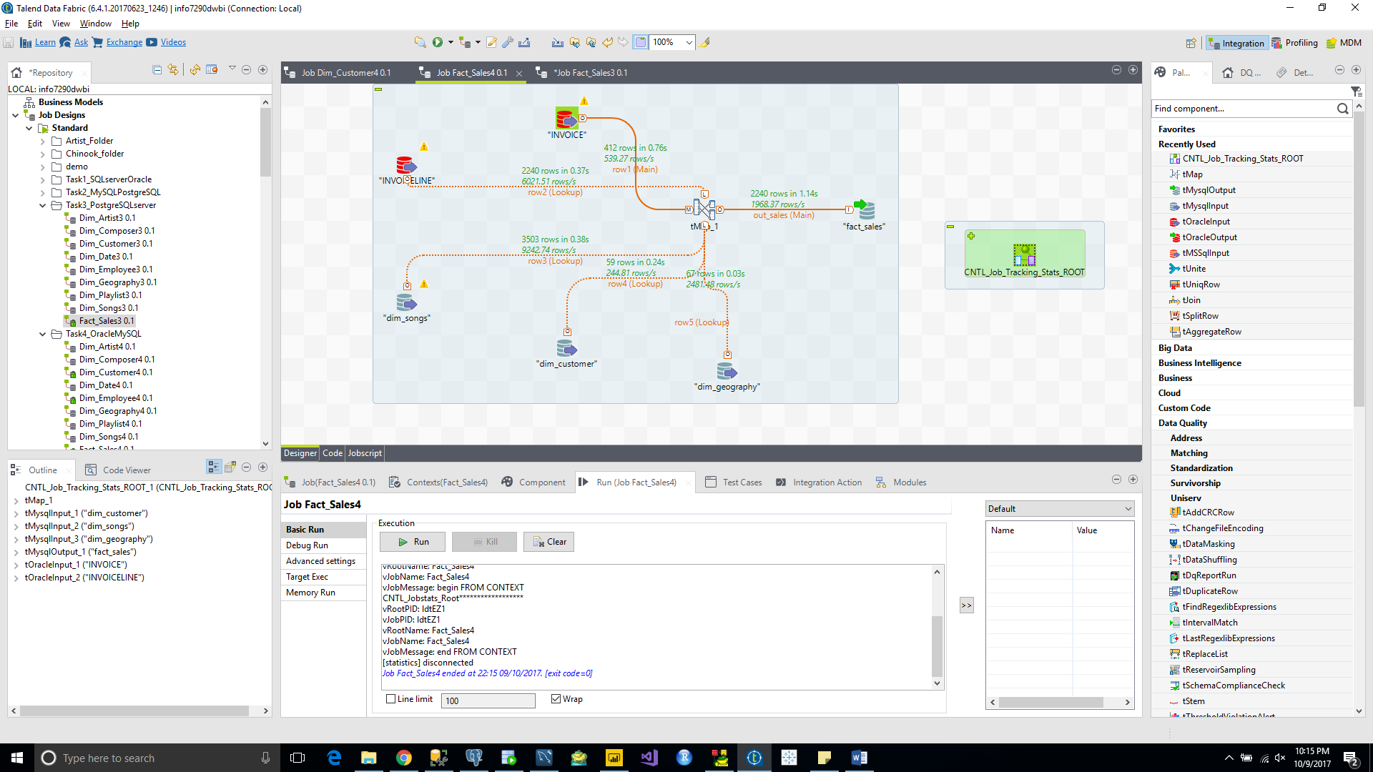

**Destination Data Warehouse row count of each tables**

SQL server : Chinook_dw_t

|  |  |  |
| --- | --- | --- |
| **Sl.No** | **Table Names** | **Row Count** |
| 1 | Dim_Artist | 275 |
| 2 | Dim_Composer | 853 |
| 3 | Dim_Customer | 59 |
| 4 | Dim_Date | 45655 |
| 5 | dim_Employee | 8 |
| 6 | Dim_Geography | 67 |
| 7 | Dim_Playlist | 8715 |
| 8 | Dim_Songs | 3503 |
| 9 | Fact_Sales | 2240 |

MySQL: Chinook_dw_t

|  |  |  |
| --- | --- | --- |
| **Sl.No** | **Table Names** | **Row Count** |
| 1 | Dim_Artist | 275 |
| 2 | Dim_Composer | 853 |
| 3 | Dim_Customer | 59 |
| 4 | Dim_Date | 45655 |
| 5 | dim_Employee | 8 |
| 6 | Dim_Geography | 67 |
| 7 | Dim_Playlist | 8715 |
| 8 | Dim_Songs | 3503 |
| 9 | Fact_Sales | 2240 |

PostgreSQL: Chinook_dw_t

|  |  |  |
| --- | --- | --- |
| **Sl.No** | **Table Names** | **Row Count** |
| 1 | Dim_Artist | 275 |
| 2 | Dim_Composer | 853 |
| 3 | Dim_Customer | 59 |
| 4 | Dim_Date | 45655 |
| 5 | dim_Employee | 8 |
| 6 | Dim_Geography | 67 |
| 7 | Dim_Playlist | 8715 |
| 8 | Dim_Songs | 3503 |
| 9 | Fact_Sales | 2240 |

Oracle: Chinook_dw_t

|  |  |  |
| --- | --- | --- |
| **Sl.No** | **Table Names** | **Row Count** |
| 1 | Dim_Artist | 275 |
| 2 | Dim_Composer | 853 |
| 3 | Dim_Customer | 59 |
| 4 | Dim_Date | 45655 |
| 5 | dim_Employee | 8 |
| 6 | Dim_Geography | 67 |
| 7 | Dim_Playlist | 8715 |
| 8 | Dim_Songs | 3503 |
| 9 | Fact_Sales | 2240 |